Welcome, Bonjour, Tansi!
Welcome to the Winter Storytime Programming kit. The purpose of this kit is to introduce children to the joys of winters in Canada in a fun and an educational manner. The Wapiti team hopes this kit makes storytime easy and convenient.
Each program is based around a Suggested Storytime Plan. The Winter storytime program includes:
- Book Description List
- Opening Songs
- Puppet Activities
- Flannel Stories & Songs
- “Get the Wiggles Out” Activities
- Goodbye Songs
- Craft Activities
- Inventory List
- Feedback Sheets

Upon completion, please fill out one of the feedback sheets located in the back of the manual. Your comments and suggestions will help us improve our programming kits.
Happy educating!

Team Wapiti

Suggested Story Time Layout
As mentioned, each program is based around a Suggested Storytime Plan, located on page 3. This plan is not a strict rule librarians must follow. The suggested plan can be adapted and used as inspiration for your audience.
Using the Suggested Storytime Plan we suggest using the following layout.

Example:
- Welcome song
- Puppet activity
- Story #1
- Get the Wiggles Out activity
- Flannel story
- Story #2
- Story #3
- Goodbye song
- Related craft

Once again, these are simply suggestions and intended to inspire an interactive and educational story time. Feel free to adapt as necessary.

Winter Storytime
Date:
Week:
Books:
- Younger Crowd:
  - 1) Little Penguins
  - 2) So Much Snow!
  - 3) Polar Bear Night
- Mixed Crowd:
  - 1) Perfect Snow
  - 2) Over and Under the Snow
  - 3) First Snow
- Older Crowd:
  - 1) The Hockey Sweater
  - 2) So Much Snow!
  - 3) Over and Under the Snow

Opening Songs/Rhymes:
- “Hello Friends” - Sign Language
  - Credit: Jbrary YouTube
- “Good Morning”
  - Tune: Shoo Fly!

Puppet Activity:
- “There was a little Penguin”
  - Book pairing: Little Penguins
  - Puppets used: Penguin

“Get the Wiggles Out” Activities:
- “Boots, Jacket, Scarf and Hat”
  - Tune: Head, shoulders, knees and toes
- “Play in the Snow”
  - Tune: ‘round the Mulberry Bush
- “Snowball time”
  - Tune:
- “Banana’s Unite!”
  - Credit: Jbrary YouTube

Early Literacy Tip: Show kids the importance of books!
Make sure books are place in an area of importance in their room, ensuring they are a focal point.

Flannel Stories & Songs:
- “Little Snowball”
  - Suggested book pairing: Perfect Snow
- “Five Snowmen”
  - Suggested book pairing: First Snow
- “Six Little Penguins”
  - Suggested book pairing: Little Penguins

Provided Book Information
Goodbye Song:
- “Goodbye Friends” – Sign Language
  - Credit: Jbrary YouTube
- “It’s Time to Say Goodbye”
  - Tune: If you’re happy and you know it

Craft Activity:
- Melting Snowman
- Doily Snowman
- Paper Heart Penguins
- Colouring sheets

- Title: First Snow
By: Peter McCarty
Description: Pedro has never before seen or felt snow, he does not think he will enjoy the cold snow. Pedro is visiting his cousins and they can’t wait to show him all the joys of snow. In this tale, Pedro experiences his first snowball, first snow angel and first sled run.
Suggested Audience: Ages 4- 8

- Title: Little Penguins
By: Cynthia Rylant
Description: Little penguins put on their mittens, scarves and boots so they can play in the deep snow outside their home. Beautiful illustrations accompany this heartwarming tale.
Suggested Audience: Ages 3- 7

- Title: Over and Under the Snow
By: Kate Messner
Description: A young boy and his father go cross country skiing in a forest and appreciate nature. A gently crafted tale which beautifully captures natures wonders.
Suggested Audience: Ages 4- 8

- Title: Over at the Rink- A hockey counting book
By: Stella Partheniou Grasso
Description: Set to the catchy rhythm of the traditional counting rhyme Over in the Meadow, Over at the Rink is the perfect way to count all the reasons we love hockey.
Suggested Audience: Ages 3- 7

- Title: Perfect Snow
By: Barbara Reid
Description: Scott and Jim cannot wait for recess because last night’s snowfall delivered them the most perfect snow. Accompany these two boys as they build snowmen, snow forts and a perfect snow surprise.
Suggested Audience: Ages 3- 8

- Title: Polar Bear Night
By: Lauren Thompson
Description: A young polar bear goes on a magical journey late one night. The little cub sets out for the snow, the sky, the sea, and the ice.
Suggested Audience: Ages 3- 6

- Title: Snow Day!
By: Werner Zimmermann
Description: This tale celebrates the excitement and the joy children experience when a snow day is announced. Two boys scramble outdoors for hockey and building snow forts.
Suggested Audience: Ages 3- 7

- Title: So Much Snow!
By: Robert Munsch
Description: A blizzard has arrived but Jasmine is determined to make it to school.This classic Munsch tale will have children laughing as Jasmine goes deeper, and deeper, and deeper into the snow.
Suggested Audience: Ages 2- 7

- Title: The Hockey Sweater
By: Roch Carrier
Description: A Canadian classic tale about what happens when young Roch’s Montreal Canadiens hockey sweater becomes too small and too shabby to wear.
Suggested Audience: Ages 3- 8
- Title: Winter, Winter, Cold and Snow
By: Sharon Gibson Palermo
Description: Chickadee, Bear, Rabbit and other friendly animals go on a quiet exploration on a beautiful winter day.
Suggested Audience: Ages 4-8

- Title: Z is for Zamboni: A hockey alphabet
By: Matt Napier
Description: This book is an excellent tool for kids to learn about ice hockey and its heroes.
Suggested Audience: Ages 3-8

Welcome Songs
Welcome songs are a wonderful tool to help get kids attention focused. Singing songs gets children ready to participate and excited for what will happen next. Worried about your singing voice? Don’t, the kids don’t mind.
- “Hello Friends”
Actions: Uses Sign Language, two simple actions
View: Jbrary YouTube https://www.youtube.com/watch?v=tKCGF2hvq3I

Lyrics:
Hello, friends. (x3)
It's time to say hello.
- “Good Morning”
Tune: Shoo Fly!

Lyrics:
Good morning, everyone,
Good morning, everyone,
Good morning, everyone,
Are you ready for some fun?

Stand up and turn around,
Then sit down on the ground,
Give me a great big CLAP!
Now fold your hands in your lap.

Puppets in the Library
Why Use Puppets?
- Puppets can give meaning to stories and bring classical characters to life.
- Puppets provide a context for a conversation between a character and yourself.
- Puppets can help break down barriers because they aren’t threatening, building a relationship between yourself and new children.

Tips:
- The internet and YouTube provide countless examples of innovative ways to include puppets into your story time.
- We recommend checking out
  - Jbrary blog
  - Pinterest
  - “Puppets in the Library” by Allison Taylor-McBryde YouTube video
Link: https://www.youtube.com/watch?v=oyUQhmSj66s&feature=youtu.be

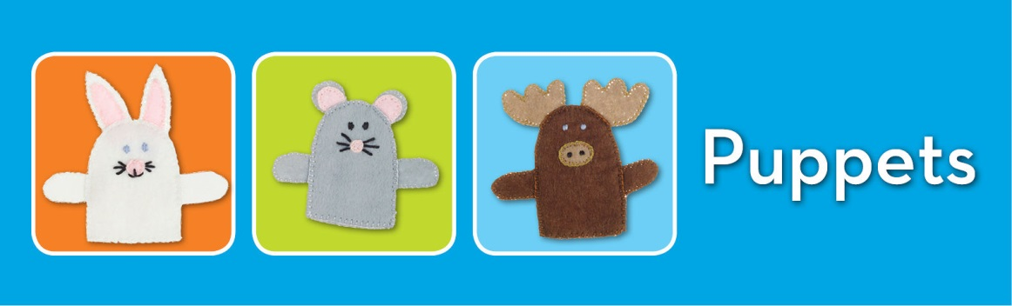

Puppet Activity

The Canada storytime kit includes a beaver puppet and a selection of animal finger puppets.

- “There was a little Penguin”
(Perform actions with penguin puppet to words)

Lyrics:
There was a little penguin,
Who lived in a box,
He swam in the ocean,
He climbed on the ice.
He snapped at a fish,
He snapped at a polar bear,
He snapped at a whale,
He snapped at me,
He caught the fish,
He caught that polar bear,
He caught that whale,
But he didn't catch me!

- “Pete the Penguin”
Tune: Tiny Tim

Lyrics:

I had a little penguin,
His name was peculiar Pete,
I put him in the bathtub,
To see if he could swim.

He drank up all the water,
He ate up all the soap,
And now he’s home sick in bed,
With bubbles in his throat.

Flannel Stories & Songs

Flannel stories provide an intriguing medium for telling a story. The bold colours capture children’s attention and teach them visual literacy. Pointing to colours and counting out shapes are fantastic ways to get participation from your group.
- Snowball, snowball?
Description: Simple rhyme, similar to “Little Mouse, little mouse”
Felts provided: 6 mittens and 1 snowball
Suggested book pairing: First Snow
Set up: Place all the mittens on the board. Then tell them to cover their eyes and hide the snowball behind one mitten. Repeat the tune until the snowball is revealed.

Lyrics:
Snowball, snowball,
Cold and round,
Behind which mitten,
Can you be found?

- “Five Little Snowmen on a Sled”
Felts Provided: 5 snowmen, 1 Frosty, 1 snowdoctor, 1 sled
Suggested Book Pairing: First Snow

Lyrics:

Five little snowmen riding on the sled
One fell off and bumped his head
Frosty called the doctor and the doctor said
"No more snowmen, riding on that sled!"
Four little snowmen... etc. (Continue until you reach zero)
- Five Little Snowmen & Mr. Sun
Description: Simple counting rhyme
Felts provided: 5 snowmen and 1 sun.
Suggested book pairing: Perfect Snow

Lyrics:

Five little snowmen all made of snow,
five little snowmen standing in a row.
Out came the sun and stayed all day
and one little snowman melted away.

Four little snowmen all made of snow,
four little snowmen standing in a row.
Out came the sun and stayed all day
and one little snowman melted away.

(Continue to countdown snowmen)
Three little snowmen all made of snow…
Two little snowmen all made of snow…
One little snowman all made of snow…

(Finish with…)
Zero little snowmen all made of snow,
zero little snowmen standing in a row.
Down came the snow that fell all day
and five little snowmen came back to play.

“Get the Wiggles Out” Activities

It is natural for children to get antsy during storytime. “Get the Wiggles Out” are fun interactive activities aimed at shedding some of the kid’s energy. These activities also pair physical actions to their accompanying words, making fun songs educational moments.

- The Snowkey Pokey
Tune: Hockey Pokey
(Perform actions to words)

Lyrics:

You put your right mitten in,
You take you right mitten out,
You put your right mitten in and you shake it all about.
You do the Snowkey Pokey,
And you turn yourself around.
That’s what it’s all about!

Additional Lyrics
You put your left mitten in…
You put your scarf in…
You put your right/left boot in…
You put your hat in…

- “This is the way we Play in the Snow”
Tune: All ‘Round the Mulberry Bush
(Perform actions to words)

Lyrics:
This is the way we STOMP in the snow,
STOMP in the snow,
STOMP in the snow,
This is the way we STOMP in the snow,
When we go out to play.

Additional Lyrics
This is the way we HOP in the snow…
This is the way we SPIN in the snow…
This is the way we CRAWL in the snow…
This is the way we SIT in the snow…

- Make Some Snowballs
Tune: Are you Sleeping?
(Perform actions to words)

Lyrics:
Snow is falling, snow is falling,
(Flutter fingers down)
All around, all around,
(Spin around)
Come let’s make some snowballs, come let’s make some snowballs,
(Pretend to make a snowball with hands)
Throw them here, throw them there, (Pretend to throw)

- “Dance Little Snowflake”
Tune: Frere Jacques with performed actions.
(Perform actions to words)

Lyrics:

Dance little snowflake, dance little snowflake, (Dance)
Dance around the town, (Spin around)
Dance upon your tiptoes, (Stand on tiptoes)
Dance from side to side, (Sway from side to side)
Twirling up and down, twirling up and down, (Move hands up and down)
While you dance around the town, (Spin and sit)

- “Banana’s Unite!” (Jbrary YouTube)
Description: A silly chant, perform actions along with lyrics

Lyrics:
Banana’s Unite! (Bring arms above head to form a banana)
Peel bananas, peel, peel bananas
Peel bananas, peel, peel bananas
Peel bananas, peel, peel bananas
(Bring arms down to sides)
Additional verses:
Chop bananas, chop, chop, bananas (repeat 3 times)
(Pretend arms are knives and chop in front of you)
Eat bananas, eat, eat, bananas (repeat 3 times)
(Pretend to eat bananas with both hands)
Go bananas, go, go, bananas (repeat 3 times)
(Jump up and down, spin around, be silly)
Goodbye Songs

Goodbye songs indicate to the kids that storytime is over and invites them to participate again. They can be paired to reiterate the message shared in the opening song.

- “Goodbye Friends”
Actions: Uses Sign Language, two simple actions
View: Jbrary YouTube https://www.youtube.com/watch?v=tKCGF2hvq3I

Lyrics:
Goodbye, friends. (x3)
It's time to say goodbye.

- “It’s Time to Say Goodbye”
Tune: If you’re Happy and you Know it

Lyrics:
Oh it’s time to say goodbye to our friends, (clap, clap)
Oh it’s time to say goodbye to our friends, (clap, clap)
Storytime is done today,
So come back again another day,
It’s time to say goodbye to our friends. (clap, clap)

Craft Activities
- Melting Snowman

Description
Pre-cut white snowballs and attach together with duo-tang clips in advance, this will allow for the snowball to melt.
Depending on your crowd, arms, hats, noses, eyes and scarves can be cut out in advance.

Materials
Pre-cut cardstock snowballs
Pre-cut construction paper embellishments or stickers
Scissors
Glue
Pencils and crayons
Duo-tang clips

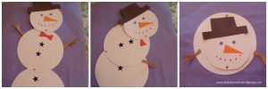

- Paper Heart Penguin

Description
Create this adorable goose by cutting out: 1 large black oval, 1 medium sized white heart, 3 small orange hearts. Assemble by gluing as demonstrated in the example. Liberties can be taken with decoration.

Materials
Construction paper
Scissors
Glue
Pencils & crayons
Optional: Googly eyes, feathers
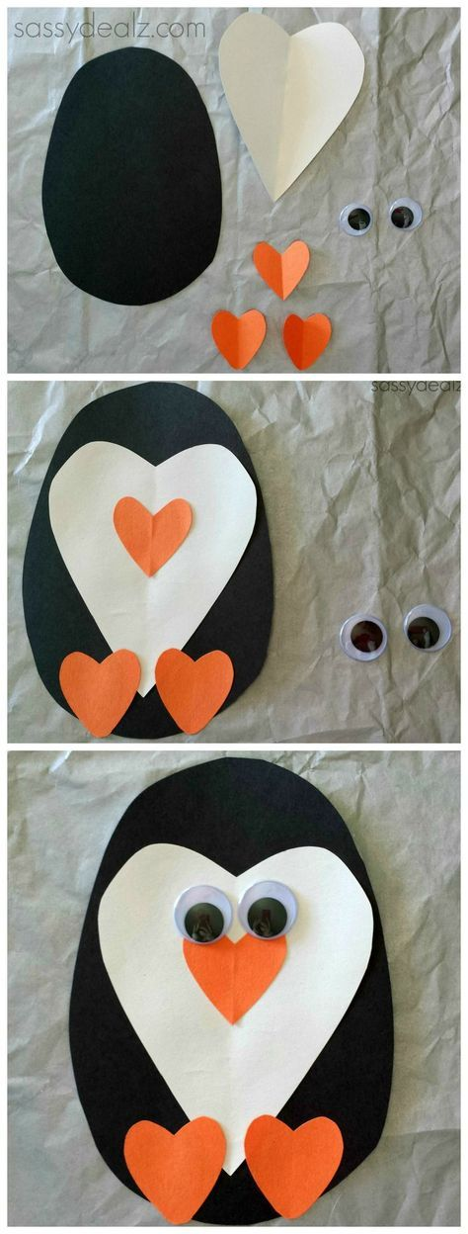

- Delightful Doily Snowman

Description
Glue two doilies, smaller one on top or the larger one onto a piece of construction paper. Cut out in advance hats, scarves, arms and noses. Have the kids decorate as desired.

Materials
White paper doilies
Construction paper
Glue Sticks
Buttons
Optional: Chalk (for background), cotton balls, googly eyes.

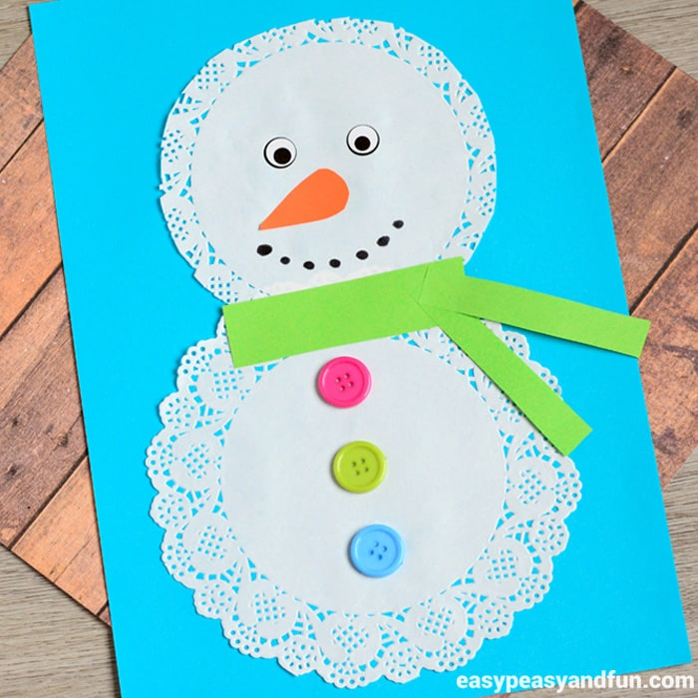

Inventory
Books
Item | Quantity
First Snow  By: Peter McCarthy | 1
Little Penguins  By: Cynthia Rylant | 1
Over and Under the Snow  By: Kate Messner | 1
Over at the Rink- A hockey counting book  By: Stella Partheniou Grasso | 1
Perfect Snow  By: Barbara Reid | 1
Polar Bear Night  By: Lauren Thompson | 1
Snow Day!  By: Werner Zimmermann | 1
So Much Snow!  By: Robert Munsch | 1
The Hockey Sweater  By: Roch Carrier | 1
Winter, Winter, Cold and Snow  By: Sharon Gibson Palermo | 1
Z if for Zamboni- A hockey alphabet  By: Matt Napier | 1
Puppets & Flannel Stories
Penguin | 1
Finger Puppets (assorted) | 10
3 in 1 Portable Easel | 1
Snowball, Snowball? | 5 mittens, 1 snowball
Five Little Snowmen on a Sled | 5 snowmen, 1 frosty, 1 doctor, 1 sleigh
Five Little and Mr. Sun | 5 snowmen, 1 sun

Feedback
- Please fill out the following form after completion of the Winter Storytime kit and place at front of binder.
- Thank you for your feedback!
Date:
Library:
Librarian:
Attendance:
Were the provided materials sufficient and helpful? | Please circle one: Yes No  Other:
1 5 10
Please rate each category on a scale of 1 to 10.
Weak Moderate Strong

- Book selection:
- Flannel Stories:
- Puppet Activity:
- Craft Activities:
How could we improve the Winter storytime kit?
What did you enjoy about the Winter storytime kit?
- Other comments:

