Help for your Kobo or other eInk Reader
Compatible Formats: EPUB, OEPUB, PDF
Downloading items to your Kobo or other eInk e-book reader does require the use of a computer. You will need to download the item to your computer first, then add it to your reader using free software.
How to Download items for your Kobo
1 | 2 | 3 | 4 | 5
Download Adobe Digital Editions.  Create an Adobe ID and authorize your Kobo. | Plug your Kobo into your computer.  Select “Manage Library” or “Connect” on the Kobo screen. | Search or browse for a title you are interested in, and check it out. | Download. | Drag the book onto your Kobo.

- Download Adobe Digital Editions (ADE) and install it on your computer. For more information on installing and using ADE, please see the “Adobe Digital Editions” handout.
In order to use ADE to transfer items to your e-reader, you will have to make an Adobe ID. This ID allows you to read a downloaded eBook on multiple devices, including e-book readers. For more information on how to set up Adobe Digital Editions with an Adobe ID, please see the “Adobe Digital Editions” handout.
Enter your Adobe ID information here in case you need it later.
Adobe ID (email):
Password:

- Plug your Kobo/e-reader into your computer using the USB cable that came with it.
On the screen of the Kobo itself (NOT your computer), a message may come up. Choose “Manage Library” (for older Kobos) or “Connect” (for newer Kobos). For some Kobos, as well as other brands of e-book readers, nothing will appear on your screen. That’s fine - skip this step.

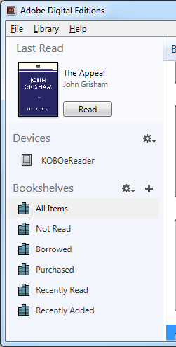 | When your e-book reader is successfully connected to your computer, it should show up at the top of the list of Bookshelves, under “Devices” (as shown at left).  The exact name may vary depending on what type of reader you have.
- Now you will be able to download eBooks. Return to the library website (http://www.sclibrary.ab.ca/download.htm) and find a title you are interested in on one of the e-book services the library offers. For more help with these services, see Help for OverDrive | Help for Freading | Help for OpenLibrary.
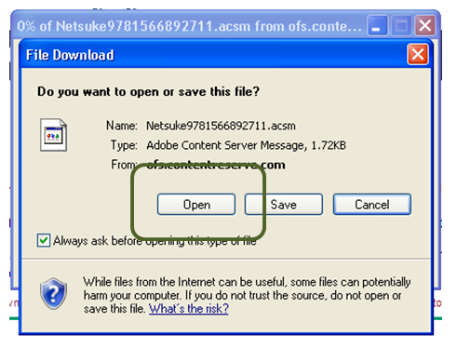 | - Download the e-book you have chosen. If your computer prompts you what to do with the file, choose “open.”  When you select Open, Adobe Digital Editions will load with the book you just downloaded.
- Your selected eBook will download and load in Adobe Digital Editions. The book will automatically load in reading view. To switch back to an overview of all your items, click on the “Library” button (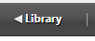). The book you just downloaded should now appear on your “All Items” and “Borrowed” Bookshelves.
To add a borrowed eBook to your Kobo, drag and drop the book from the main Library screen to “KOBOeReader” (or whatever name your e-reader appears under). When your cursor is over the name of your reader, you will see it turn into a little green “plus” sign. This means that the book will be added to your Kobo. When you release the mouse button, you may see the item being transferred, although sometimes this happens so fast it is difficult to see.
Returning an Item Early
If you have an e-book checked out, but you are finished reading it, you can return it early. This allows you to check out a new title (if you are at your limit of 5 checkouts) and also frees up the book for another patron to borrow.
To return an item early, go to your Library view, if you are not already there. Right click on the cover of the item you want to delete. A menu will appear with options for that title. Click on “Return borrowed item.”
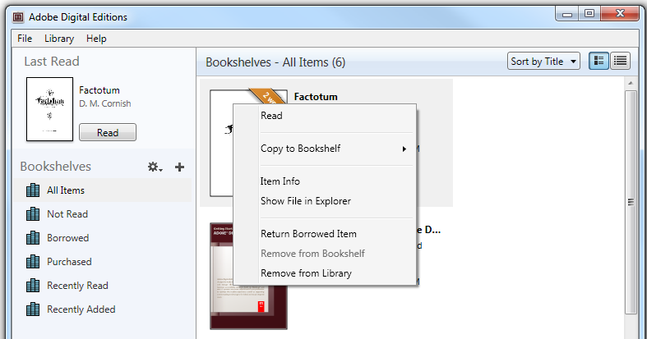
Note: This action cannot be undone. However, you are welcome to borrow that title from the library again in the future.
Some file types cannot be returned early
EPUB and PDF ebooks can be returned early.
OEPUB and OPDF ebooks cannot be returned early. If you check out one of these books, set it to a shorter checkout period, or delete it from your device and then wait for it to expire from your account.

For more help with Adobe Digital Editions, you may want to visit the Adobe website at http://www.adobe.com/support/digitaleditions/
If you have any questions, please feel free to contact us:
Phone: 780.410-8601 | Email: info@sclibrary.ab.ca | or stop by one of our Information Desks
Last updated: January, 2013

