E-Books on Overdrive:

iPad, iPad mini, iPhone & iPod Touches
- Download the Overdrive Media Console App
» Visit the Apple App Store

Search for Overdrive Media Console.

Click Install / Download button.

You will be prompted to enter your Apple ID and Apple ID password.

If you have forgotten your apple id password you can reset password. Apple will send you a “reset password “ link to your email.

The app will start downloading and installing on your iPad.

Troubleshooting if app does not open after installing:

Restart your device.
- Press and hold the Sleep/Wake button on the top of the device until the “Slide to Power Off” button appears and tap the button.
- Press the Sleep/Wake button again to restart.
Still doesn't work? Uninstall and reinstall the app.

From now all actions will take place inside the app.

NOTE: Steps 1- 4 only need to be done once for the initial step up.

- Create an Overdrive Account

Open the OverDrive app and follow the prompts to create an OverDrive account and log in.

If you're under 13, select I am under 13 years old instead.

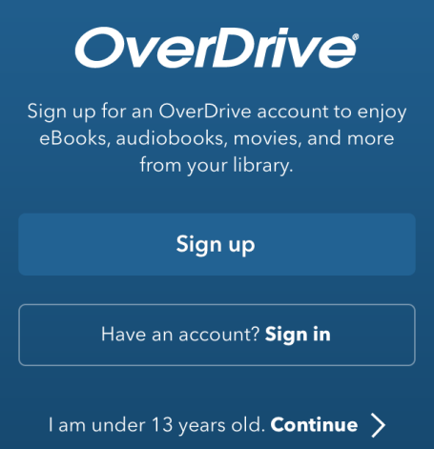

After you sign up for an OverDrive account, you can automatically activate new devices for your account when you sign in on each one. You can have up to six devices synced and authorized with your account.

- Open up the Home Menus

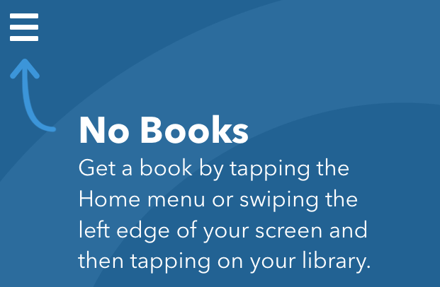

Once you open up the OverDrive app, swipe from left to right to open the Home menu.

- Add your library to the app

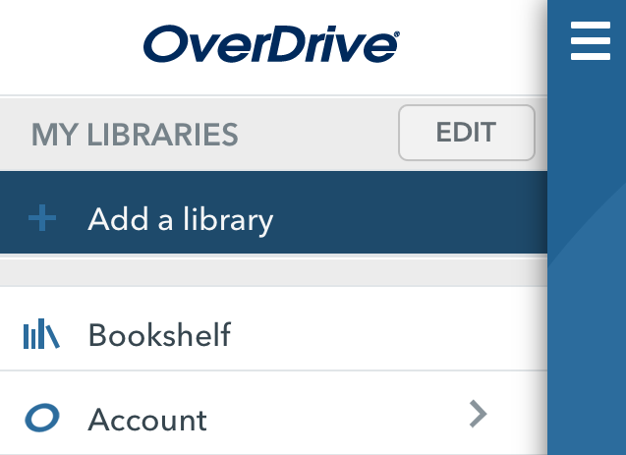

Tap Add a library to find your library's OverDrive website.

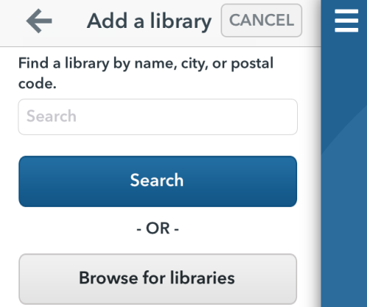
Search for your library by typing in :

- Greater Victoria Public Library
- OR Victoria BC
- OR your postal code

OR Browse for your library by country, then province and then by name of library

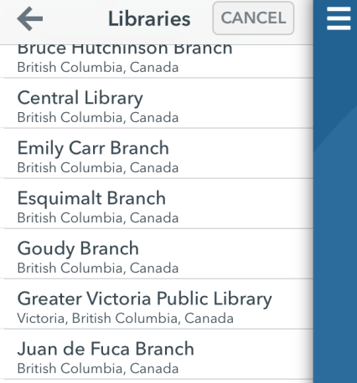
Click on the link that says: Greater Victoria Public Library

You will be presented with two libraries
- GVPL Library to Go
- British Columbia Libraries

Click on the star beside each library to make them your favourites.

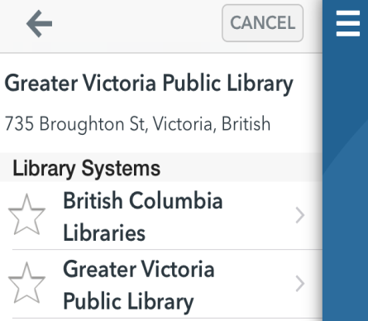

You are now finished the initial set up. You will not have to do this again. You are now ready to check out e-books.

- Sign In To Your Library Account

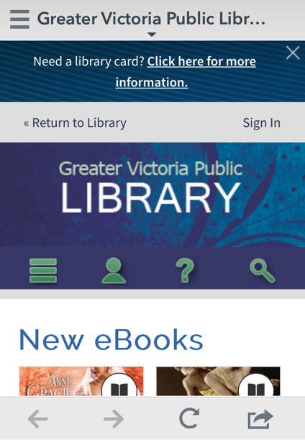
Click on the person icon to sign in with your library barcode and password. You must have a valid GVPL library card in order to access e-books and audiobooks.

Once you have signed in to your account you may want to change your default loan period [which is 14 days].

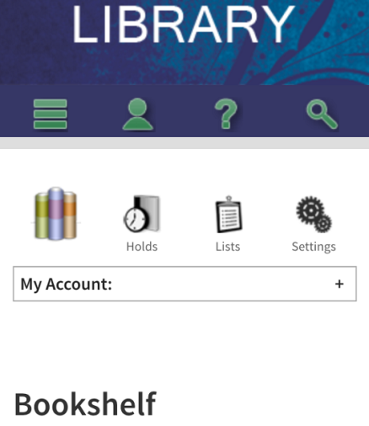

To change your loan period to either 7 or 21 days click on the Settings button in your account to choose your loan period: 7 days, 14 days or 21 days, then click the Save button- the system will then change the default loan period for your account.

- Browse the collection or search for a specific title.
Tap the GVPL Library to Go Menu Button to start browsing the collection
OR
Tap the Search symbol (magnifying glass) to search for a particular author or title.

Browsing the collection: Tap on any of the categories to browse that subject area and format for example e-books or audiobooks and fiction or non-fiction.. A. short list by subject area will open up – Click on “View more” to see more complete list by subject.

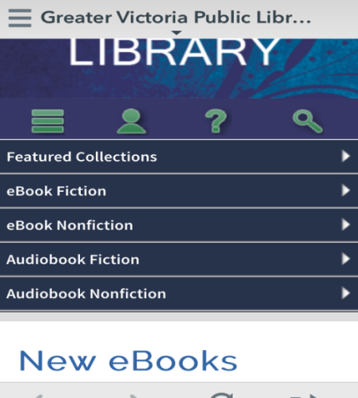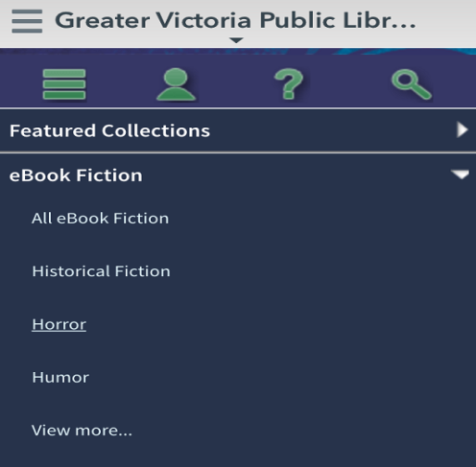
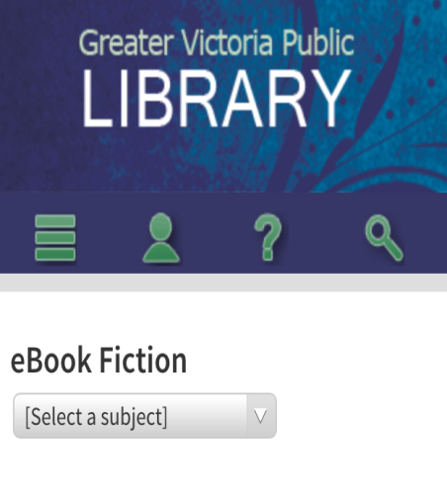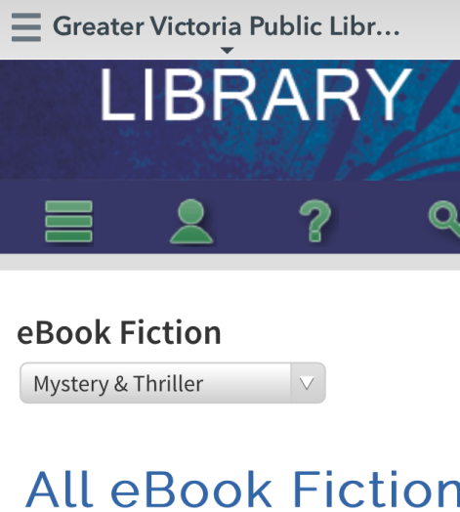
Then select a subject from the drop down menu

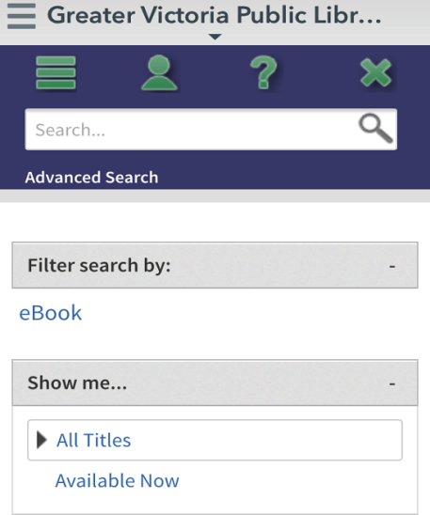
Click on Filter search by and then Available Now to show only titles available to check out immediately.
- Borrowing or Holding Items
Items available to borrow have a dark book image (or headphone image for audiobooks), items that are only available for hold have a greyed out book image (or headphone image).

O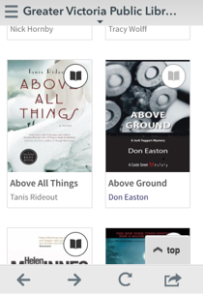

To Borrow the book tap on the centre of the image and then tap on the green Borrow button
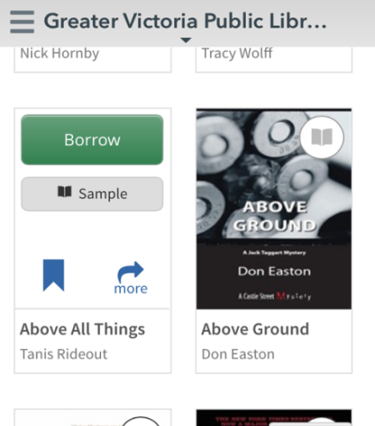
If the item is not available you can put an item on hold. To place a Hold tap the cover and then click on the Hold button. You'll be prompted to enter the email address where you wish to receive notification.

When your hold is available, you'll get an email notification, and have 48 hours to check the item out.
If you wish to automatically borrow the title when it becomes available, tick the relevant box, and then click on the Place on Hold button.

If you haven’t signed in already with your library barcode and password you will be prompted to do so. NOTE: Items only stay in your account bookshelf only for 30 minutes, so don't take too long before downloading them.

Click download to place the book on your device.

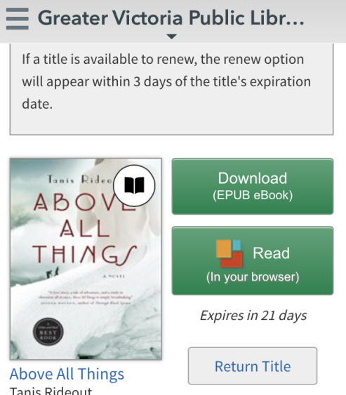
Click on download to put the e-book on your device.
NOTE: you can only return the title from this screen if you have not yet downloaded the title – once you have downloaded the title – the “Return Title” button disappears.

You may have the option to renew the book within 3 days of the expiration date if there are no other holds on it.

.
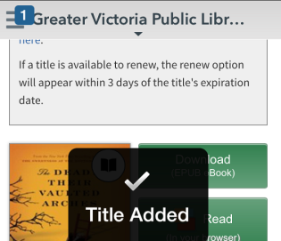
The item will start to download.
It will tell you Title Added and a small number will appear over the Menu Button. When the number disappears the item is finished downloading.
- Bookshelf
Once a book is checked out to you, it will be in the Bookshelf until its expiry date.
NOTE: This is the Overdrive app Bookshelf it is different than the Bookshelf in your digital library account. This is the bookshelf that you open your book to read.
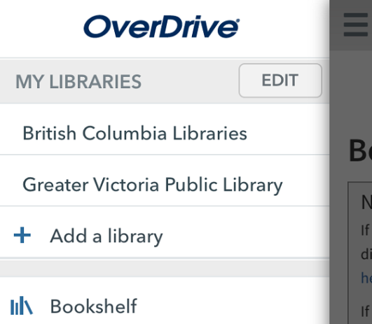
To get to the Bookshelf, click on the Menu Button in the left hand upper corner of the app screen and then click on Bookshelf.

Once you are in the Bookshelf tap on the e-book image to open (once the download is complete). Close the app when you are finished reading – it will remember the page you are on when you reopen the app.

Once you have finished reading the book tap gently in the middle of the book to bring up the Menu Button. (This also gives you access to the Font and Brightness menus). Then tap the Menu Button. You can either open another e-book on your Bookshelf, return the finished e-book early or find another e-book or audiobook to download.

How do I return my eBooks?

You don't have to! When the lending period is up, the book will automatically expire and be returned for you.

Can I return an eBook early so I can borrow other titles? Yes!

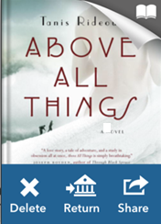

Go to the Bookshelf.

Tap and hold the cover of the eBook you want to return or delete, until a blue bar appears at the bottom of the cover. Tap Return and then tap When it asks you "Are you sure you want to return this title?" Tap the Return symbol again.

