Downloading eBooks to Your Nook

**Before You Begin**

• Make sure you have downloaded and installed the free **Adobe Digital Editions** software on your computer. *(See separate instruction sheet)*

• Go to <http://tln.lib.overdrive.com/> and select an eBook of your choice.

**Checking Out**

1. When you have found an eBook that you would like to check out, click **Add to My Cart across from the Adobe EPUB. This is the format that will work with your NOOK.**

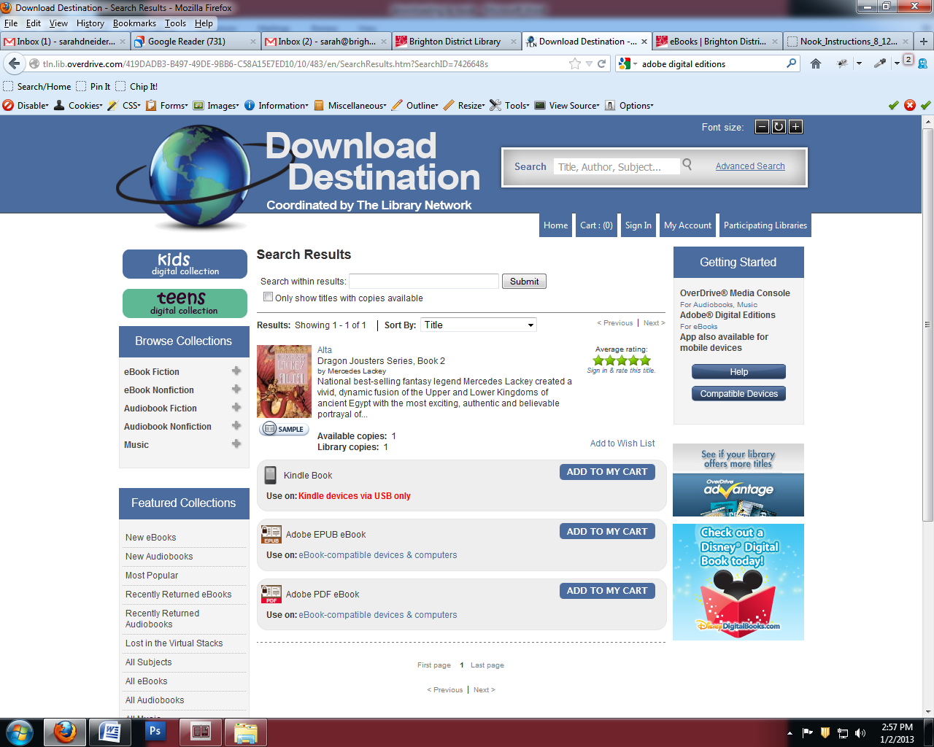

**2.** If you'd like to keep looking for additional titles, select "Continue Browsing." Otherwise, click on **Proceed to Checkout**.

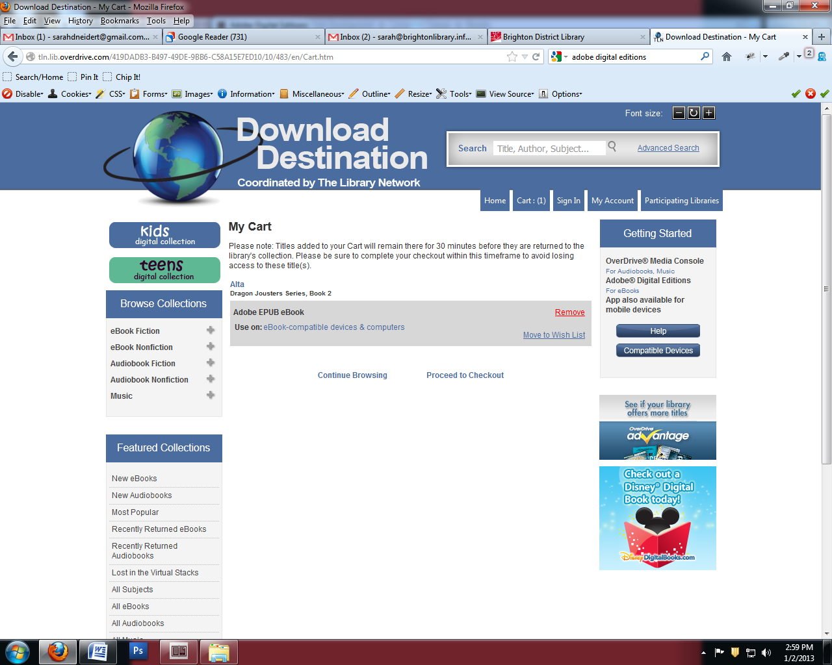

3. Sign in to your library account by entering your **Library card number**.  
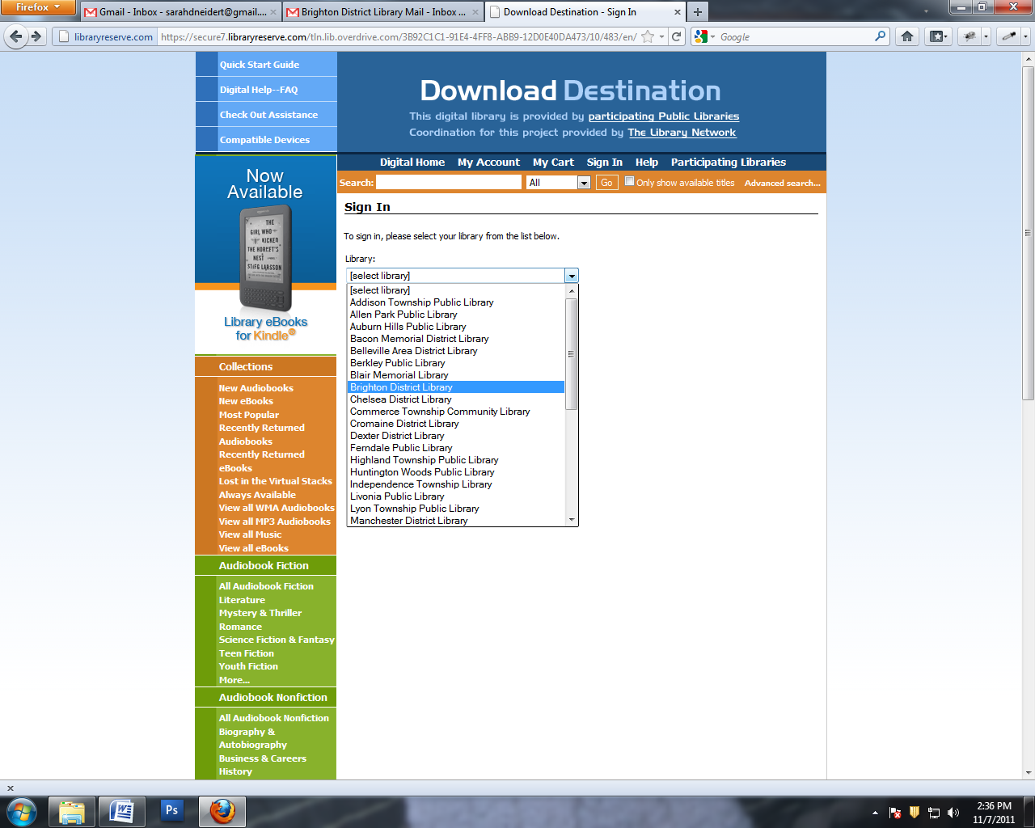  
**4. Sign in with your library card (NO SPACES) and PIN.**  
 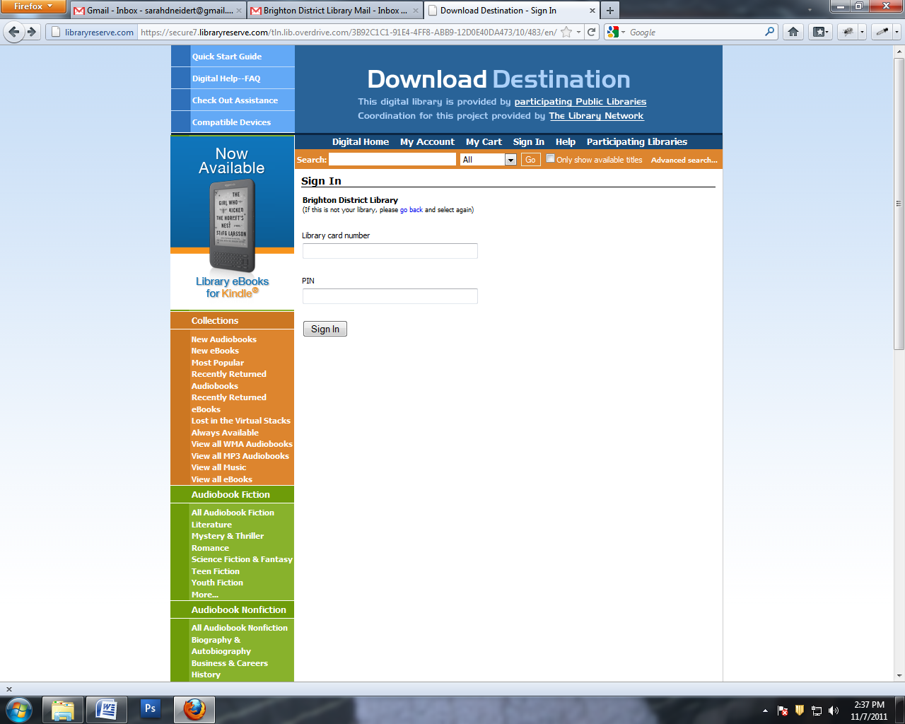

**4.** Select your **lending period** then click on **Confirm check out**.

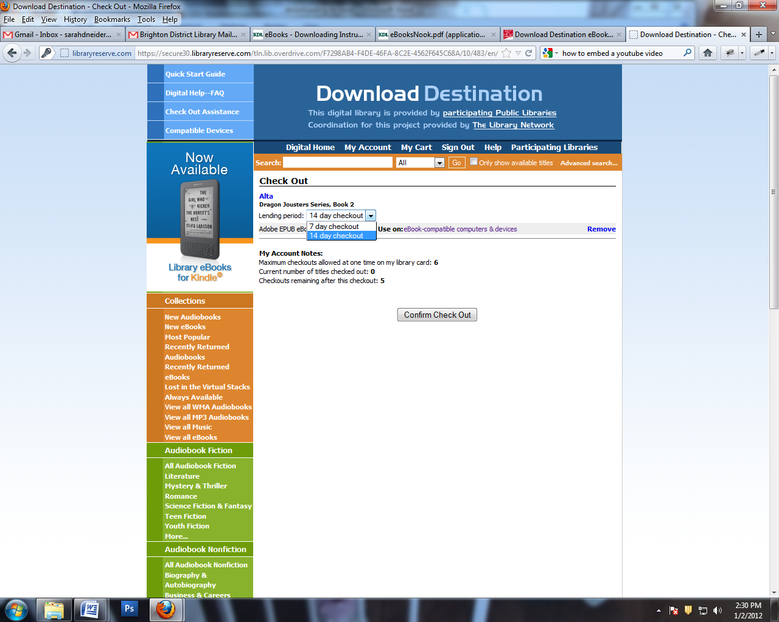

**Downloading and Transferring**

1. Click the **Download** button under the book's cover image.

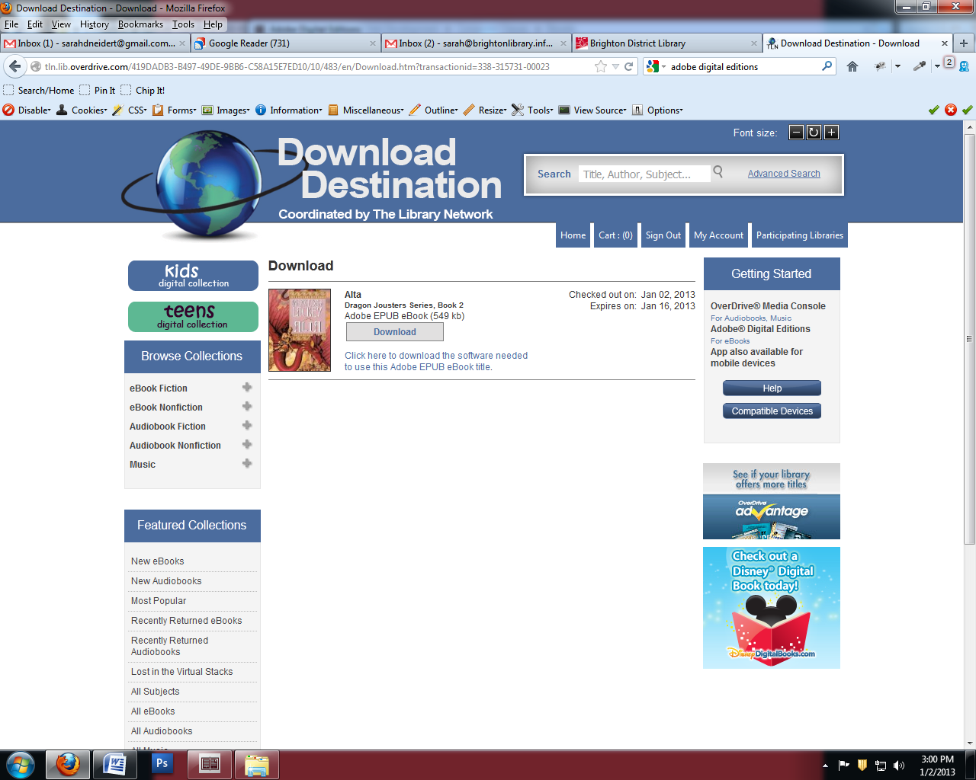

1. When asked whether to Open or Save the file, select **Open** with Adobe Digital Editions

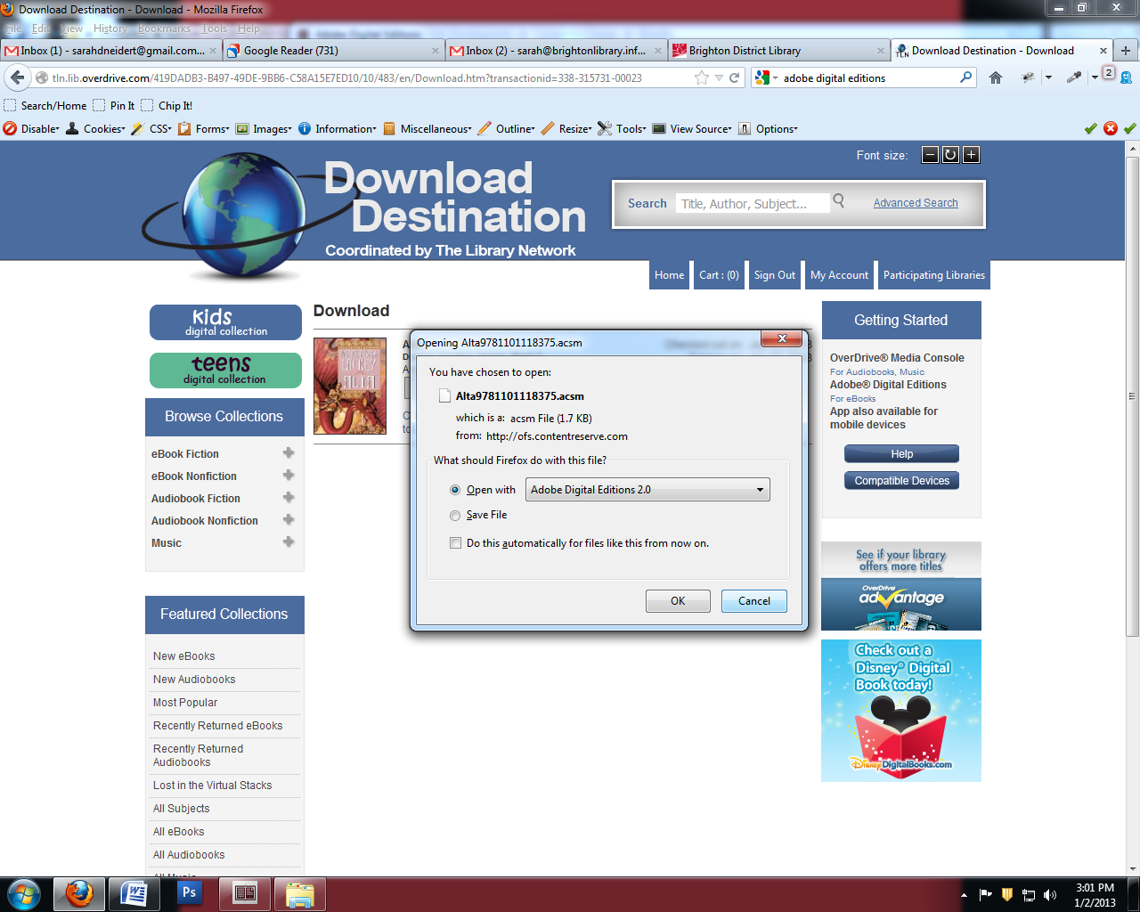

1. Adobe Digital Editions will open and your eBook will download. This is the “Reading View” and you can read your book right on the screen.

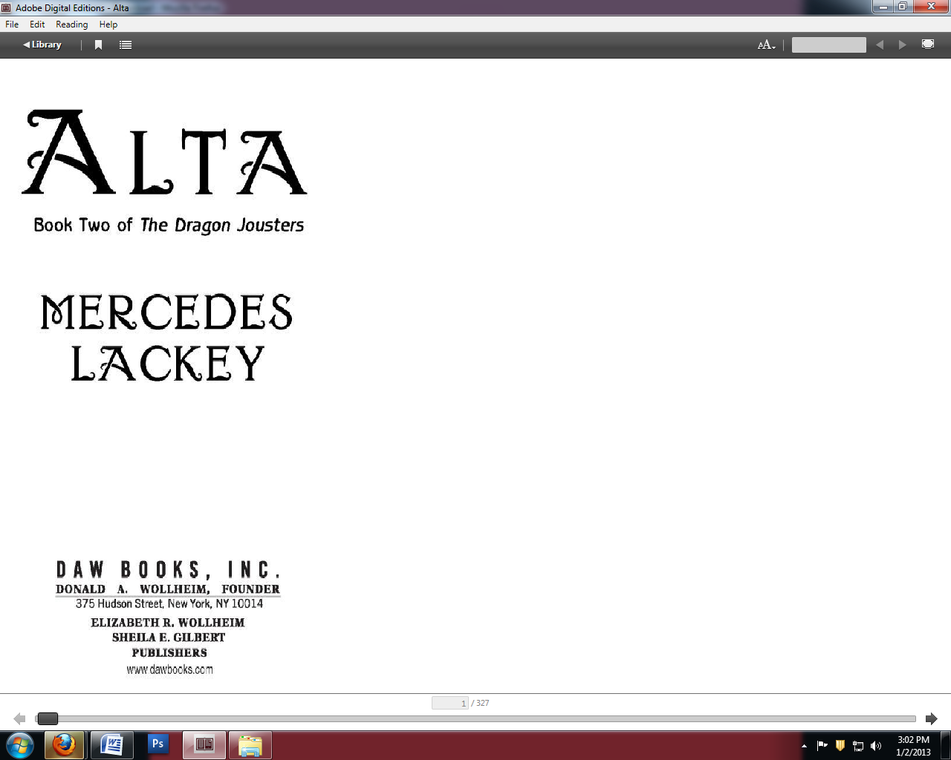

**3.** Plug your Nook into your computer using its USB cable.

*(If this is the first time you have used your Nook with Adobe Digital Editions, a Setup Assistant will open. Click* ***Authorize Device****.)*

1. When in Library view, your Nook should be listed in the left column of the screen, under “devices” with any eBooks you have downloaded on the right.
   1. To transfer an eBook to your Nook, **drag and drop** the eBook from the right side of the screen onto the Nook icon. This will copy the file onto your device.
   2. You can also ***right click*** on the title and choose “copy to computer/device” and choose the **NOOK**.

Right click on the book.

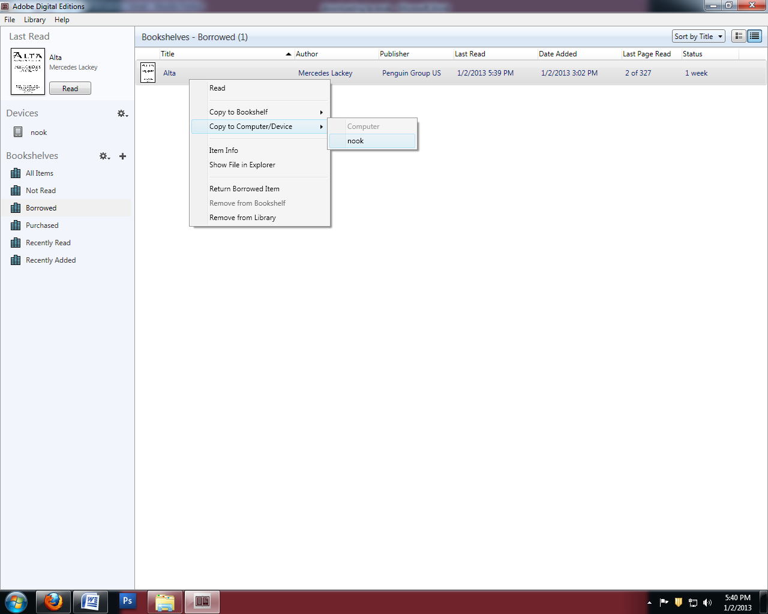

Your device is here

**To delete or return an item early:**Right click on the title you wish to return or delete and select the option you want.

