Get to Know the Internet

Handout
GLOSSARY
Blog: A website that is typically in journal format and covers various topics such as a travel, news, etc. In many cases, blogs provide regular updates on the activities of that site or person who created the blog. Someone who keeps a blog is known as a blogger, although many companies will also have a blog as part of their larger websites.
Broadband: Any high-speed Internet access that is always on and is faster than traditional dial-up.
Browser: Computer software that allows users to view information on the World Wide Web. It converts computer language (HTML) into images and text onto the screen. Some of the most popular browsers are Firefox, Chrome, Safari, Opera and Microsoft Explorer/Edge.
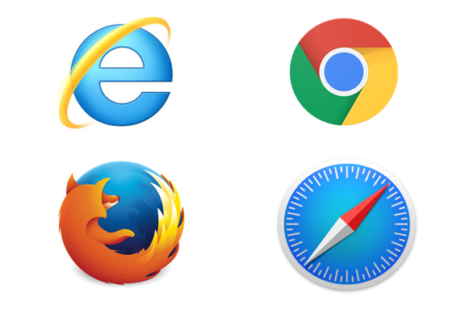
(Google) Chrome
(Microsoft)Internet Explorer (older)/
Edge (newer)

(Apple/MAC)
Safari
(Mozilla) Firefox
- Browser Window: A box that has information in it.
Browser window

- Browser Tab: Goes inside a browser window so you can see multiple pages by selecting a tab. (Think of these as tabs in a binder that separate different pages or information. The browser window would be the binder.)
Data (cellular data or mobile data): The transmission of data via cellphones which allows access to the internet via cellular signals.
Data Centre: Building or room that houses servers.
Database: A website that collects information together and organizes it. Databases sometimes require a subscription and are sometimes accessible through a library.
Device: Any electronic equipment that can connect to the Internet, such as computers, laptops, phones, tablets, etc.
Dial up: A connection to an Internet Service Provider that can be created over a conventional telephone line.
Domain Name Server (DNS): Acts as a kind of directory by searching for the address or webpage you want to view.
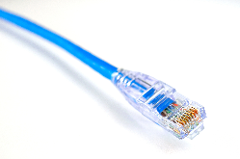
DSL: A broadband connection that uses a phone line to connect to the Internet, but is faster than a dial up connection.
Ethernet cable: A cable that connects devices on local area networks such as PCs, routers and modems.
Home page: The main page of a website, often called the landing page. This term can also refer to the default page that appears when a user opens a browser. This default home page can be changed by the user at any time.
Internet: A vast computer network linking smaller computer networks. These networks allow for the sharing of vast amounts of information in different formats, such as text on a website.
Internet Service Provider (ISP): An organization that provides service for accessing and using the Internet. Some local examples are TekSavvy, Novus, Shaw and Telus.
Intranet: A private network of computers inside a company for internal use.
IP address: A numerical label assigned to each device (e.g. computer, printer) participating in a computer network.
Links: Text or images that are connected to another location. By clicking on a link, the user is taken to another part of the page, to another page on the website or to a different website altogether.
Login: The account name used to gain access to a site or resource such as an email account. It is also an action (i.e. to login to an account).
Modem: A device used to connect a computer or router to a telephone line for connectivity to the Internet.
Navigation bar: A set of links, icons and images that allows the user to move through a series of web pages. Similar to a toolbar in a word processing document.
Network: Computers that are connected together to share resources.
Search engine: A website that searches the World Wide Web when the user types words into a search box.
Server: A system that provides service to computers, allowing access to the Internet or email (e.g., Shaw, Telus).
URL (Uniform Resource Locator): Unique web address on the internet. It is what is displayed in the address bar and enables you to go to a specific website.
Web page: A single document, file or page accessible on the Internet and viewed using a browser. A series of web pages are usually linked together to form a website.
Wireless/Wi-Fi: Use of the Internet through a laptop, cell phone, or other mobile device without any physical cable connection. Connection is made using radio waves rather than electronically along cable wires or phone lines.
Wireless Router: A device needed for a wireless/Wi-Fi network to connect a modem to broadcast to other devices nearby. Some modems come with a wireless router built in.
World Wide Web (WWW): sometimes just called “the Web”, refers to a network of online content that can be viewed with a browser. Made of millions of interlinked webpages that can be searched with a search engine.

MATCH THE DEFINITION TO THE PICTURE

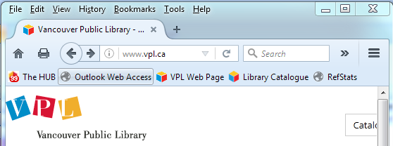
1 2 3 4 5 6 7

_____ Home button: Click Home to go back to your pre-set home page. Ours is www.vpl.ca.

_____ Address bar: The address of the website you are looking at. You can type a new address here to move to another page.

_____ Print button: Click Print to print the page you’re looking at.

_____ Refresh button: Click Refresh to try to get a site again if it’s taking a very long time. Sometimes shows as X or Stop.

_____ Back button: Click Back to go back to the last page you were looking at. A Forward arrow will appear once you’ve gone back.

_____ Search box: This is where you input words to look for on the Internet and find websites when you don’t know the address.

_____ Scroll bar: Use the scroll bar to see content lower down on the page.

LEARN MORE
VPL Events Guide | For days, times and locations, check out the “Computer & Technology” category in our Events Calendar. You can also look in the paper brochure “VPL Classes & Workshops”. | www.vpl.ca/events
VPL Computer Practice Drop-In | A drop-in to practice new skills with information staff assistance. | Central Library  Tuesdays & Thursdays  2:00 - 3:00 pm
GCFLearnFree.org tutorials | Free online tutorials for learning a range of essential skills including computer, technology and internet skills. | www.gcflearnfree.org
VPL Information Services | We are here to help!  If you have any further questions, please ask us! | Phone: 604-331-3603 Email: info@vpl.ca
VPL Research  Guides | Computer Survival Guide  Information and self-directed practice activities on introductory computer and Internet topics. | guides.vpl.ca/computers

Videos in this class
Where does the Internet come from?
- https://edu.gcfglobal.org/en/internetbasics/what-is-the-internet/1/
Computer Basics: Connecting to the Internet
- https://edu.gcfglobal.org/en/computerbasics/connecting-to-the-internet/1/
YouTube: Browser Tabs & Windows
- https://www.youtube.com/watch?v=d8gs5iwsZAY

