Get the Most Out Of Internet Searching

Description
Get the most out your Internet searching in this hands-on, introductory class. Learn how to effectively use search engines such as Google, review search results and critique websites. Basic ability to use a keyboard and mouse is required. Register by phone for this or other classes in the Internet Essentials series. Each class must be registered for separately.

Learning Goals > OUTCOMES
Digital Proficiency > Navigate > Read information in digital formats
Learners will be able to . . .
- Read and interpret information presented in common media, multimedia and transmedia formats
- Identify and locate common types of digital information sources
Digital Proficiency > Navigate > Navigate search tools & results
Learners will be able to . . .
- Define an information need and determine the best information sources to meet it
- Recognize and use the search features of digital information sources
- Identify, assess, and iterate search terms and strategies
Digital Proficiency > Navigate > Critically evaluate digital information
Learners will be able to . . .
- Critically evaluate information sources in context to infer how authority, context, format, URL, publisher, affiliation, bias and other factors contribute to reliability
- Evaluate, compare and contrast product and service information found online including both commercial and social services

Preparation

Equipment Needed: | - Computers for learners  - Projector/computer  - Internet access  - Sound
Materials Needed: | - PowerPoint on usb  - Handouts/evaluation forms for learners
Setup Procedures: | - Review the “Adult Teaching & Learning at VPL” teaching philosophy: http://hub.vpl.ca/content/85898  - Review the lesson materials  - Confirm that all necessary space and equipment has been booked
Background Reading | - http://www.agoogleaday.com/  - See slides for background reading on each topic
# of Staff Required and/or Staff:Learner Ratio | - 1-5 learners: 1 instructor  - 6-12 learners: 2 instructors  - For branch meeting room capacities, please see: http://hub.vpl.ca/content/64490

Opening
Before doors open:
- Write your name and programs@vpl.ca on the whiteboard (include phone number 604-331-3603 for more basic digital literacy classes)
- Distribute handouts, digital essentials flyers, evaluation forms (if applicable)
- Test internet & speakers
- Turn the computers for learners on before class starts
- Open any relevant websites needed for lesson.

As learners enter
- Welcome learners

Lesson

Slideshow/Webpages | LEARNING ACTIVITIES |  |  | LEARNING OUTCOMES
Slide/Show | Time | Trainer Does | Learners Do
 | 2 min | INTRODUCTION  Welcome students; introduce yourself; introduce the class and series  Remind learners of washroom locations; turn off cell phones; etc.  Ask if everyone can hear you. | - Listen to instructor
 | 5 min | LEARNING OPPORTUNTITIES AT VPL  - This is one of several Digital Essentials series offered for free here at the library.  Click on the link in slide to navigate to vpl.ca Digital Essentials page and show learners other classes.  Refer to Digital Essentials flyer  - You can work toward a certificate for each series. If you attend all classes in the series, you will receive a certificate in the last class in the series.  - Next week’s class is on Internet Privacy. | - Listen to instructor  - Ask questions
 | 3 min | LEARNING OPPORTUNTITIES AT VPL  - There are several ways you can learn more about this topic. One way is through online learning at your own pace.  VPL Research Guides  https://www.vpl.ca/researchguides  - Wide variety of topics; collected books & online resources  Show them how to find the Research Guides from the VPL website and how to navigate to the Internet Essentials guide | - Listen to instructor  - Ask questions
 | 1 min | LEARNING OPPORTUNITIES AT VPL  - This is one of many learning opportunities at the library.  - Today’s class is meant to be an introduction to the topic – there are lots more ways to delve deeper.  - There are many other ways to learn and get help on this and other topics at the library  - Drop in to any branch  - Computer Drop-In Practice at Central  - Call or email the library | - Listen to instructor  - Ask questions
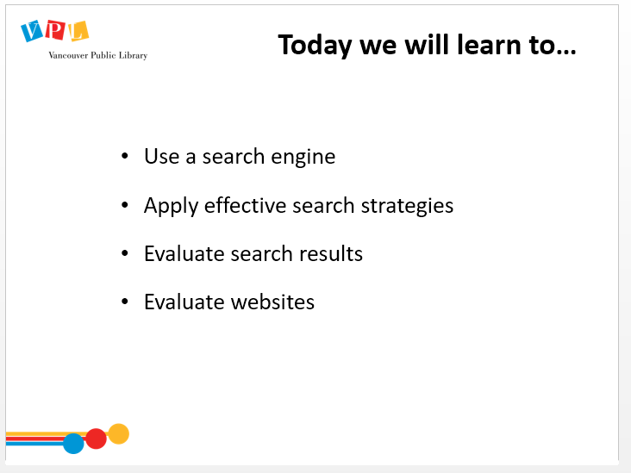 | 2 min | LEARNING OBJECTIVES  Review slide and read learning outcomes listed on slide  Lead a round where people introduce themselves and answer this question:  - Please share your name and what brings you here today. What are you hoping to learn from this class?  Ask:  - Which search engines have you used?  - Have you ever searched for something and been surprised or disappointed by the results you received?  Acknowledge each comment: any that you can do quickly, address in the moment; if it is more complex and will be addressed later in the class, let them know; if it is out of scope, indicate which other classes and resources can be used (or make a note to address this at the end of the class) | - Listen to instructor  - Respond to instructor’s prompts
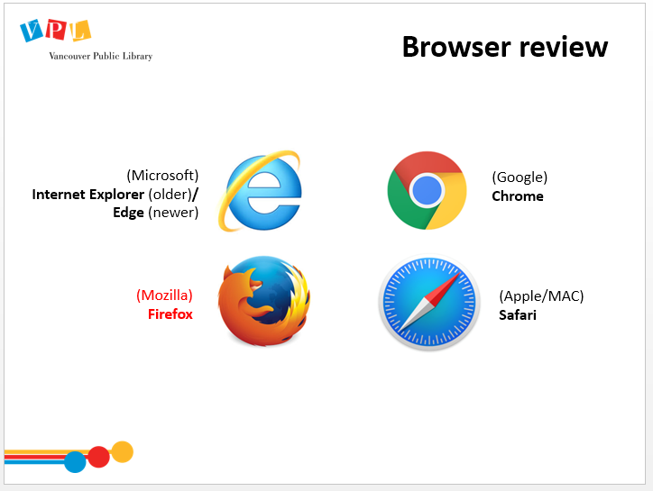 | 4 min | REVIEW BROWSERS  Explain that different browsers are slightly different, but have roughly the same layout  - We generally use and recommend Firefox because it is:  - Non-profit  - Independent  - Stable  - Works with most websites  - Protects your privacy better than other browsers (Chrome gathers a lot of data). Recommend the privacy class in this series if they are interested in this kind of information. | - Listen  - Ask Questions | - Identify and locate common types of digital information sources
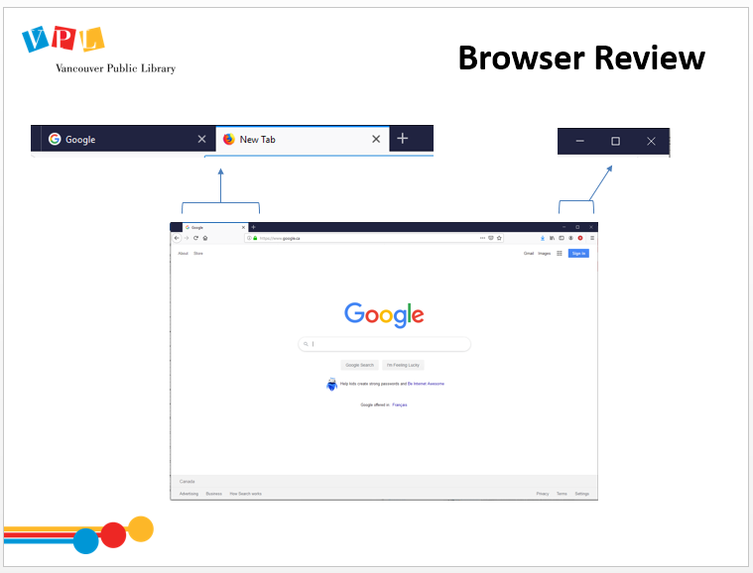 | 5 min | REVIEW BROWSER WINDOW  Direct learners to open Firefox on their computers. Ask them to practice  - Minimize, maximize, closing  - Opening a new tab  - Typing in cbc.ca into the Address bar  Open Firefox to demonstrate, if there is any confusion  Note that in some browsers, the search bar and address bar are the same thing | - Open Firefox and practice using browser features | - Identify and locate common types of digital information sources
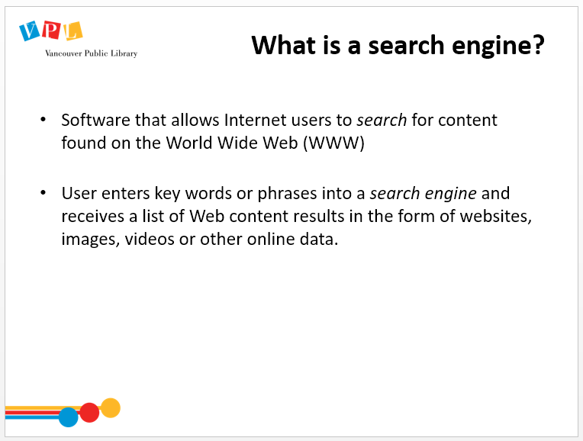 | 3 min | WHAT IS A SEARCH ENGINE?  Ask:  - What is a search engine?  Click to reveal definition on slide and read out loud  Explain the difference between a search engine and a browser | - Listen  - Ask Questions | - Recognize and use the search features of digital information sources  - Identify and locate common types of digital information sources
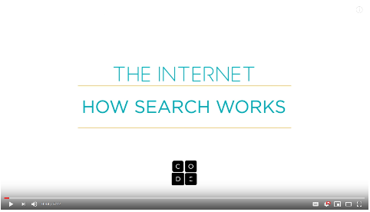 | 8 min | HOW SEARCH ENGINES WORK - VIDEO  Play video [5:12]  [Background reading for instructor: How Search Works by Google https://www.google.com/search/howsearchworks ]  Ask:  - Any questions or comments about the video?  Review any concepts that learners have questions about. | - Watch video  - Ask questions | - Recognize and use the search features of digital information sources  - Identify and locate common types of digital information sources
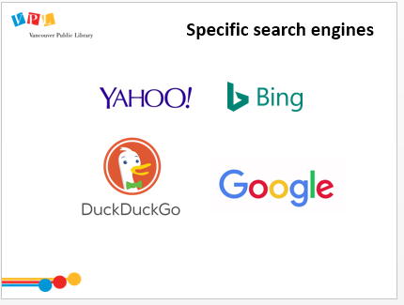 | 2 min | TYPES OF SEARCH ENGINES  - There are several different search engines including Yahoo, Bing, DuckDuckGo and Google.  - They all work in a similar way but they will each offer you different search results and have different strengths  - Google is the most popular  - Google is a huge company that makes many products, including an email service (gmail), a browser (chrome) and a search engine (just called “Google”). Sometimes, when people say “Google”, they mean the search engine, but sometimes they mean the company. The term has also become synonymous with “search the internet”.  - DuckDuckGo is one alternate search engine that doesn’t keep track of your searches.  - If you want to learn more about data collection and staying private online, come to next week’s class Let’s Talk About Online Privacy. | - Listen  - Ask Questions | - Recognize and use the search features of digital information sources  - Identify and locate common types of digital information sources
NO SLIDE | 5 min | COMPARING SEARCH RESULTS IN DIFFERENT BROWSERS  Direct learners to  - Open a Firefox browser window  - Type google.ca in address bar  - Type in “Fresh Bread” into google  - Open another window and type in “Duckduckgo.com”  - Type in “Fresh Bread” into duckduckgo  Ask learners to compare results and discuss as a group.  Discuss how to identify ads.  Discuss the different results based on the “tracking” (google) and “non-tracking” (Duckduckgo) browsers | - Practice searching  - Share | - Recognize and use the search features of digital information sources  - Identify and locate common types of digital information sources
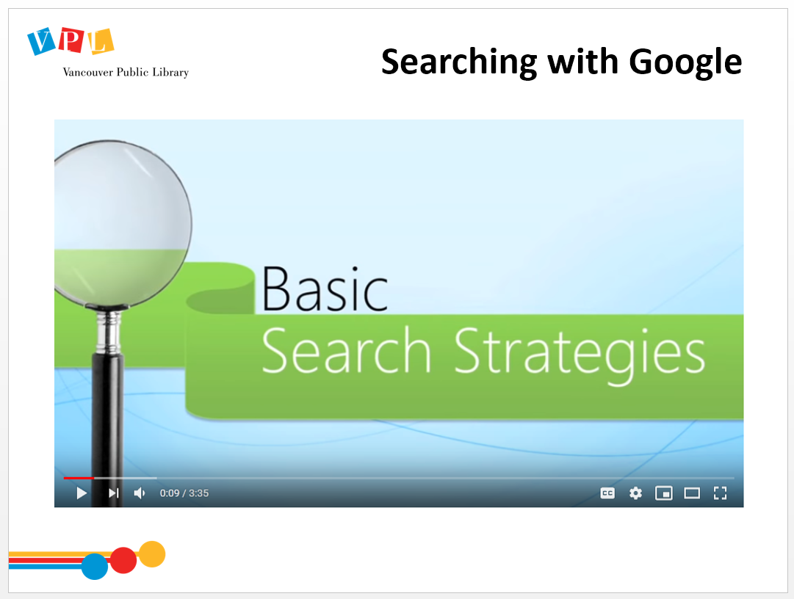 | 5 min | SEARCHING WITH GOOGLE  - This video is an overview, but we’re going to go into details about many things it covers.  Play video [3:35]  Ask:  - Any questions or comments about the video?  Review any concepts that learners have questions about. | - Watch video  - Ask questions | - Recognize and use the search features of digital information sources  - Identify, assess, and iterate search terms and strategies
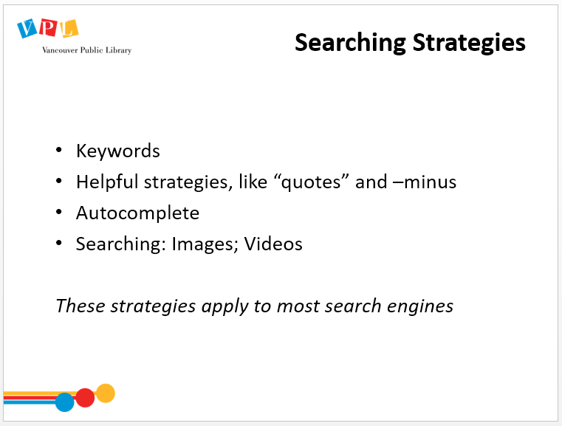 | 2 min | SEARCHING STRATEGIES  Review slide and explain how we are going to look at these search strategies in more depth  - You can use all of these strategies with Image and Video search by constructing your search query and then selecting the “Image” or “Video” tab, as shown in the video  Demonstrate in Firefox where to find the Image and Video tabs  - We’ve been using Google as an example, but I want to remind you that these features work across many different search engines | - Listen to instructor  - Ask questions | - Recognize and use the search features of digital information sources  - Identify, assess, and iterate search terms and strategies
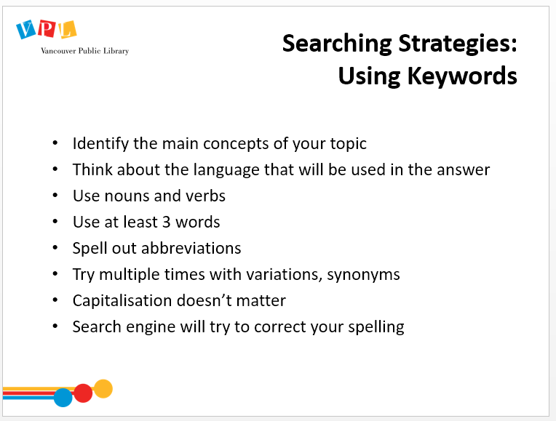 | 3 min | KEYWORDS  - You do not have to use full sentences in searches, but keywords  Review points on slide  Emphasize that you will often have to try multiple times to find the results you want, and that’s ok! | - Listen to instructor  - Ask questions | - Recognize and use the search features of digital information sources  - Identify, assess, and iterate search terms and strategies
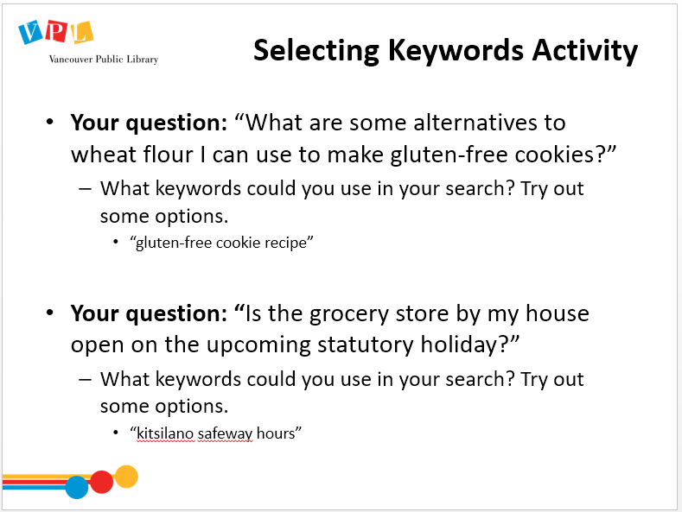 | 8 min | SELECTING KEYWORDS ACTIVITY  Direct learners to choose and search keywords for the inquiries on the slide.  Click for first question to come up.  Ask learners to try search on their own.  Review results as a group  Repeat for second question.  Explain that questions and answers will use different wording; when you’re constructing your keyword search, think about what words will appear in the answer | - Listen to instructor  - Practice searching | - Identify, assess, and iterate search terms and strategies
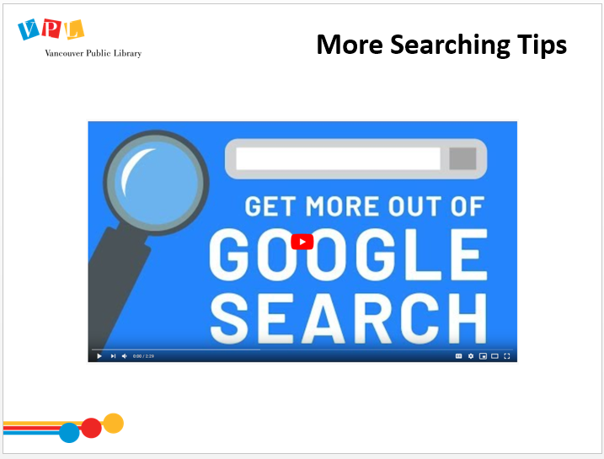 | 4 min | MORE SEARCHING TIPS – VIDEO  Play video [2:29]  Ask:  - Any questions or comments about the video?  Review any concepts that learners have questions about. | - Watch Video  - Ask Questions | - Identify, assess, and iterate search terms and strategies
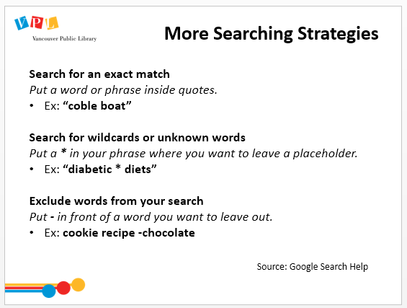 | 5 min | MORE SEARCHING STRATEGIES  Review strategies on slide. (Note that google does not support letter-specific * wildcard searches, just word based.)  Instruct learners to test these out in Firefox on their own computers.  Discuss results. | - Listen to instructor  - Practice strategies in Firefox | - Identify, assess, and iterate search terms and strategies  - Recognize and use the search features of digital information sources
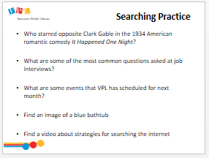 | 10 min | SEARCHING PRACTICE  Direct learners to perform searches to find the answers to one or multiple of the questions on the slide.  Encourage them to come up with their own questions.  Discuss obstacles and strategies as a group. | - Practice searching  - Ask questions  - Discuss strategies and obstacles | - Recognize and use the search features of digital information sources  - Identify, assess, and iterate search terms and strategies
 | 6  min | HOW TO READ A WEBPAGE  Play video (2:55)  Refer to handout on page 2 ‘Reading a Website’  Ask if there are any questions about the video or handout.  Ask learners to navigate to “vancouver.ca” and try out “Control F” using the term “Business” | - Watch video  - Ask questions  - Practice searching | - Read and interpret information presented in common media, multimedia and transmedia formats  - Evaluate, compare and contrast product and service information found online including both commercial and social services Critically evaluate information sources in context to infer how authority, context, format, URL, publisher, affiliation, bias and other factors contribute to reliability
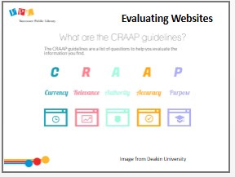 | 3 min | CRAAP GUIDELINES  Refer to handout (p. 3) with detailed explanation of CRAAP guidelines  Review each term:  - Currency: The timeliness of the information  - Relevance: Importance of the info for your needs  - Authority: source of the information  - Accuracy: reliability, truthfulness, and correctness of the content. Can you corroborate this with other, independent sources?  - Purpose: The reason the information exists | - Explore handout  - Respond to instructor prompts  - Ask questions | - Critically evaluate information sources in context to infer how authority, context, format, URL, publisher, affiliation, bias and other factors contribute to reliability
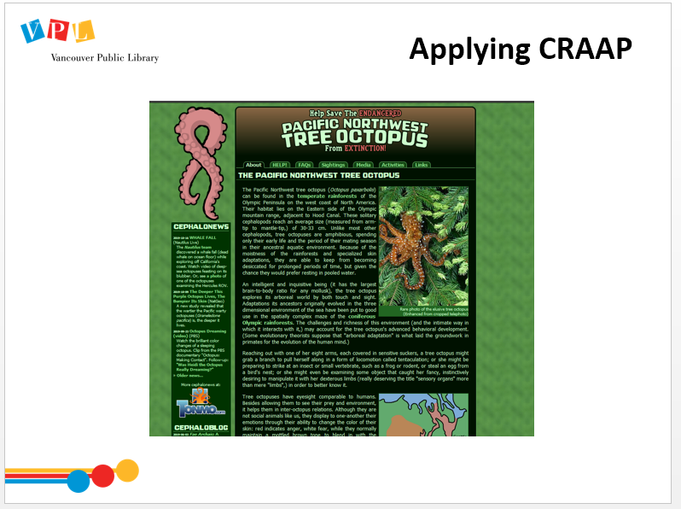 | 6 min | APPLYING CRAAP  Navigate to Pacific Northwest Tree Octopus website (https://zapatopi.net/treeoctopus/) by clicking on the image in the slide.  Review CRAAP guidelines in reference to this site.  - CURRENCY - looking at the footer tells us the site was created in 1998, and last updated in May of 2018  - RELEVANCE - the audience appears to be adults interested in preserving endangered species; the presence of an online store selling merchandise gives it the appearance of an organization  - AUTHORITY - the site author is someone named Lyle Zapato, whose name links to a personal website with no scientific credentials; it is clearly stated that "the site is not associated with any school or educational organization"; and the only contact information is the author's blog  - ACCURACY – Whole sections of the text are obviously incorrect, and nothing here can be corroborated from other sources.  - PURPOSE - the content makes it clear that this website is questionable  - Another tip for assessing whether what your reading is true, is to do a google search on the subject and see what else you can find on the topic  Have learners do a search on “Pacific Northwest Tree Octopus”.  Review and discuss the information on Wikipedia related to the topic that states that it is a hoax.  (Other hoax websites you can refer to: http://www.thedogisland.com; http://www.dhmo.org/) | - Listen  - Ask Questions  - Do a search | - Critically evaluate information sources in context to infer how authority, context, format, URL, publisher, affiliation, bias and other factors contribute to reliability
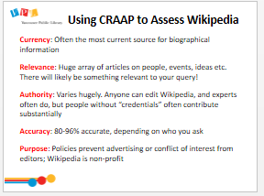 | 4 min | WIKIPEDIA  Explain what Wikipedia is (is run by non-profit; open to anyone to contribute; has editors to help maintain reliable content)  Review slide and go through CRAAP guidelines.  Open Wikipedia and click a featured article on main page  Point out that every article has sources cited at the bottom that you can use to verify the information etc. | - Listen to instructor  - Ask questions | - Critically evaluate information sources in context to infer how authority, context, format, URL, publisher, affiliation, bias and other factors contribute to reliability
 | 5 min | HOW TO SPOT FAKE NEWS  Explain “fake news” term (first meant inaccurate information, but now is used as a way to critique mainstream media by politicians such as Donald Trump…)  - Some online sources can masquerade as legitimate, but actually are misrepresenting information  - Some are done for humorous effect, but some are intentionally trying to deceive  - Anyone can post anything on the internet, making it easier to spread false information.  - Always consider who created the content, and what their motive was (A & P of CRAAP)  - Particularly pervasive on social media platforms such as Facebook  Review slide and go through the 8 points.  Refer to handout (p. 4), “How to Spot Fake News” | - Listen to instructor  - Refer to handout | - Read and interpret information presented in common media, multimedia and transmedia formats  - Critically evaluate information sources in context to infer how authority, context, format, URL, publisher, affiliation, bias and other factors contribute to reliability
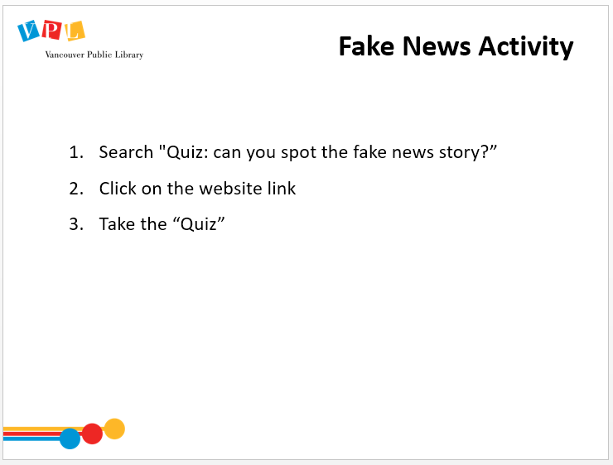 | 4 min | FAKE NEWS ACTIVITY  Direct learners to search "Quiz: can you spot the fake news story?” and complete https://www.channelone.com quiz.  Discuss results as a group. | - Complete online quiz | - Read and interpret information presented in common media, multimedia and transmedia formats  - Critically evaluate information sources in context to infer how authority, context, format, URL, publisher, affiliation, bias and other factors contribute to reliability
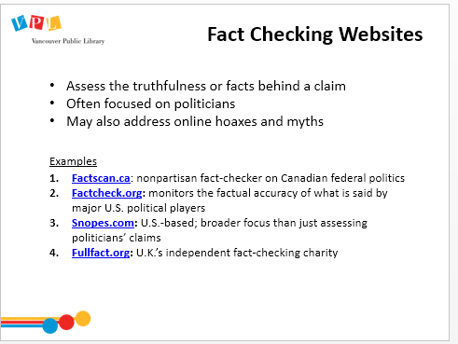 | 5 min | FACT CHECKING WEBSITES  - One way to check whether something is true is to look it up on a “fact-checking” website  Review slide to explain what a fact-checking website is  Review examples.  Navigate to Factscan.ca and show how the site works.  Navigate to snopes.com. Search snopes.com for the pacific tree octopus claim. | - Listen  - Ask Questions | - Critically evaluate information sources in context to infer how authority, context, format, URL, publisher, affiliation, bias and other factors contribute to reliability
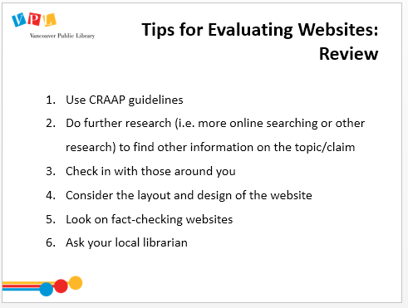 | 5 min | TIPS FOR EVALUATING WEBSITES: REVIEW  Review slide  For point 4:  - Explain how often the design (i.e. all caps, red on black background etc) of a website can be an indication of untrustworthy information  Ask:  - What other kinds of searches are likely to retrieve biased results? (ie political, opinions, anything that can be sold)  - Any other questions about evaluating websites? | - Listen  - Ask Questions  - Answer questions from instructor | - Critically evaluate information sources in context to infer how authority, context, format, URL, publisher, affiliation, bias and other factors contribute to reliability  - Evaluate, compare and contrast product and service information found online including both commercial and social services
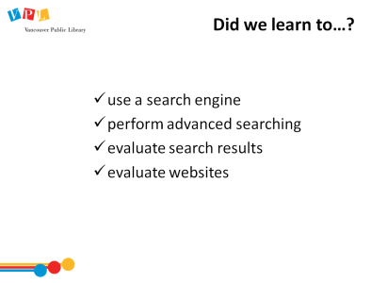 | 2 min | DID WE LEARN HOW TO?  slide  Ask:  - Do you have any other questions and/or comments?  Refer learners to resources on the handout  Remind learners about Online Privacy class next week | - Listen  - Ask Questions
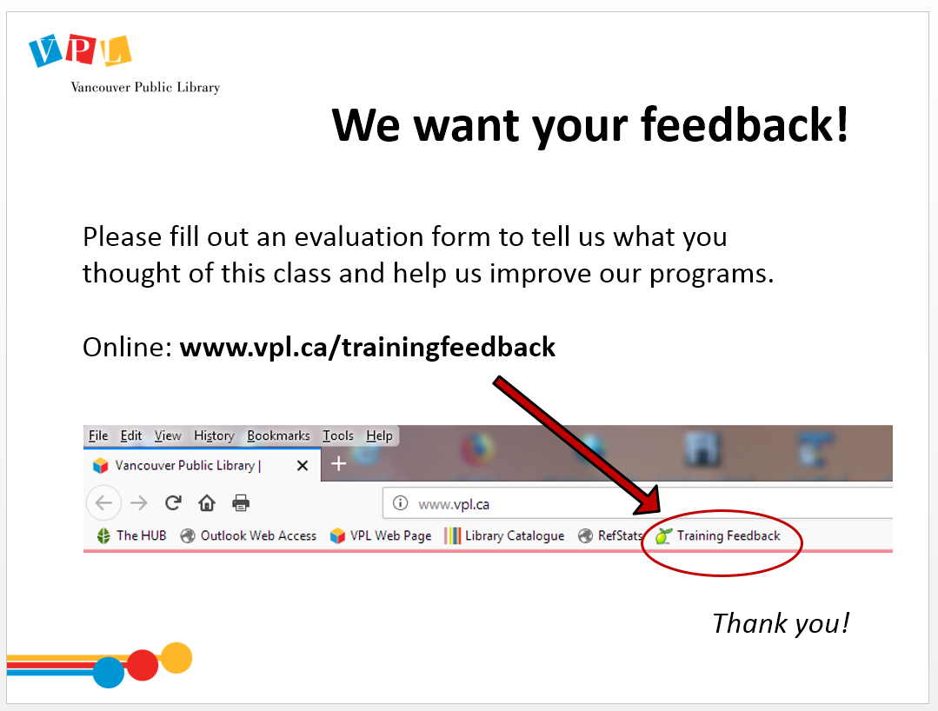 | 10 min | EVALUATION FORMS  Ask them to take some time to fill out the evaluation form. If possible, have them fill out the form online. If not, provide them with the paper forms:  - We would like your feedback! Please take some time to fill out an evaluation form to let us know what you enjoyed and what could be improved.  - There is a bookmark link to the form on all computers.  - You can also access the link by going to http://www.vpl.ca/trainingfeedback | - Fill out evaluation form

