## What is OpenOffice?

OpenOffice is a free productivity suite that is compatible with systems such Microsoft Office and the programs are very similar. For instance, many of the keyboard shortcuts, such as Ctrl+S to Save, are the same in both products.

**What can I do with OpenOffice?**

**Writer**: For word processing (compatible with Microsoft Word).

**Web:** An HTML editor (similar to Frontpage).

**Calc**: A spreadsheet program (compatible with Microsoft Excel).

**Impress**: A multimedia presentation program with slides (compatible with Powerpoint).

**Draw**: Create drawings, diagrams and illustrations (similar to Microsoft Word  
drawing tools)

OpenOffice also includes useful features like the ability to save **HTML** pages for the web as well as **PDFs** to preserve the appearance of your work when you share it with other people. OpenOffice also includes math tools that can help you with complex equations and diagrams in each of the OpenOffice programs.

## Creating a new document in OpenOffice:

Select the desired program from the OpenOffice suite. A new blank document will open.

## Converting Microsoft Office Documents

Documents created in other programs such as Microsoft Office can be opened in OpenOffice. However, some layout features and formatting attributes may not work in the same way. For instance, bullets in a text document may look differently or not appear at all.

Refer to the OpenOffice Help documents for assistance in formatting your document.

For help with Formatting in Writer:

* select **Help** > **OpenOffice.org Help**
* select the **Contents** tab, then click on **Text Documents** from the list
* select **Formatting Text Documents** from listTerminology differences:

|  |  |
| --- | --- |
| Microsoft Office XP | OpenOffice.org |
| AutoShapes | [Gallery Objects](vnd.sun.star.help://shared/text/shared/guide/gallery_insert.xhp?Language=en-US&System=WIN&UseDB=no&DbPAR=swriter) Shapes are on the **Drawing** toolbar (menu **View - Toolbars - Drawing**) |
| Change Case | [Case/Characters](vnd.sun.star.help://shared/text/shared/01/05050000.xhp?Language=en-US&System=WIN&UseDB=no&DbPAR=swriter) |
| Comments | [Notes](vnd.sun.star.help://shared/text/shared/01/04050000.xhp?Language=en-US&System=WIN&UseDB=no&DbPAR=swriter) |
| Compare and Merge Documents | [Compare](vnd.sun.star.help://shared/text/shared/guide/redlining_doccompare.xhp?Language=en-US&System=WIN&UseDB=no&DbPAR=swriter) |
| Document Map | [Navigator](vnd.sun.star.help://shared/text/shared/guide/navigator_setcursor.xhp?Language=en-US&System=WIN&UseDB=no&DbPAR=swriter) |
| Formula Auditing | [Detective](vnd.sun.star.help://scalc/text/scalc/01/06030000.xhp?Language=en-US&System=WIN&UseDB=no&DbPAR=scalc) |
| Lines and Page Breaks | [Text Flow](vnd.sun.star.help://swriter/text/swriter/01/05030200.xhp?Language=en-US&System=WIN&UseDB=no&DbPAR=swriter) |
| Mail Merge | [Form Letter](vnd.sun.star.help://swriter/text/swriter/guide/form_letters_main.xhp?Language=en-US&System=WIN&UseDB=no&DbPAR=swriter) |
| Markup | [Changes - Show](vnd.sun.star.help://shared/text/shared/01/02230200.xhp?Language=en-US&System=WIN&UseDB=no&DbPAR=swriter) |
| Phonetic Guide | [Ruby](vnd.sun.star.help://shared/text/shared/01/05060000.xhp?Language=en-US&System=WIN&UseDB=no&DbPAR=swriter) |
| PivotTable | [DataPilot](vnd.sun.star.help://scalc/text/scalc/01/12090102.xhp?Language=en-US&System=WIN&UseDB=no&DbPAR=scalc) |
| Refresh Data | [Reload](vnd.sun.star.help://shared/text/shared/02/07060000.xhp?Language=en-US&System=WIN&UseDB=no&DbPAR=swriter) |
| Replace text as you type | [AutoCorrect](vnd.sun.star.help://shared/text/shared/optionen/01010400.xhp?Language=en-US&System=WIN&UseDB=no&DbPAR=swriter) |
| Show/Hide | [Nonprinting Characters](vnd.sun.star.help://swriter/text/swriter/01/03100000.xhp?Language=en-US&System=WIN&UseDB=no&DbPAR=swriter), [Hidden Paragraphs](vnd.sun.star.help://swriter/text/swriter/01/03140000.xhp?Language=en-US&System=WIN&UseDB=no&DbPAR=swriter) |
| Spelling and Grammar | [Spellcheck](vnd.sun.star.help://shared/text/shared/01/06010000.xhp?Language=en-US&System=WIN&UseDB=no&DbPAR=swriter) |
| Track changes | [Changes - Record](vnd.sun.star.help://shared/text/shared/01/02230000.xhp?Language=en-US&System=WIN&UseDB=no&DbPAR=swriter) |
| Validation | [Validity](vnd.sun.star.help://scalc/text/scalc/01/12120000.xhp?Language=en-US&System=WIN&UseDB=no&DbPAR=scalc) |
| Workbook | [Spreadsheet](vnd.sun.star.help://scalc/text/scalc/main0503.xhp?Language=en-US&System=WIN&UseDB=no&DbPAR=scalc) |
| Worksheet | [Sheet](vnd.sun.star.help://scalc/text/scalc/01/04050000.xhp?Language=en-US&System=WIN&UseDB=no&DbPAR=scalc) |

Macros in Microsoft Office and OpenOffice.org

Microsoft Office and OpenOffice.org cannot run the same macros. If you use macros in one of the applications and want to use the same functionality in the other application, you must edit the macros. OpenOffice.org Basic IDE editor can open the macros that are contained within Microsoft Office files for you to view and edit.

## Open your document several different ways.

**Note**: OpenOffice is compatible with other programs such as Microsoft Office. These files with the following extensions will open:

* .doc (Microsoft Word)
* .xls (Microsoft Office)
* .ppt (Microsoft Powerpoint)

In the **LIBRARY ONLINE** menu box.

1. Click on **OpenOffice Suite** and then click **Start.** Another menu box will open and you can choose the program you want to use.

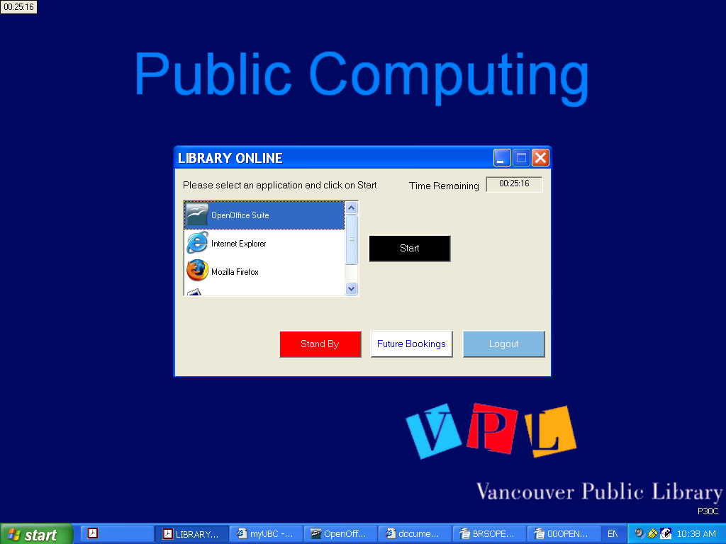

***-OR-***

2. Scroll down to **My Documents**. Click on **My Documents** and then click on **Start**.

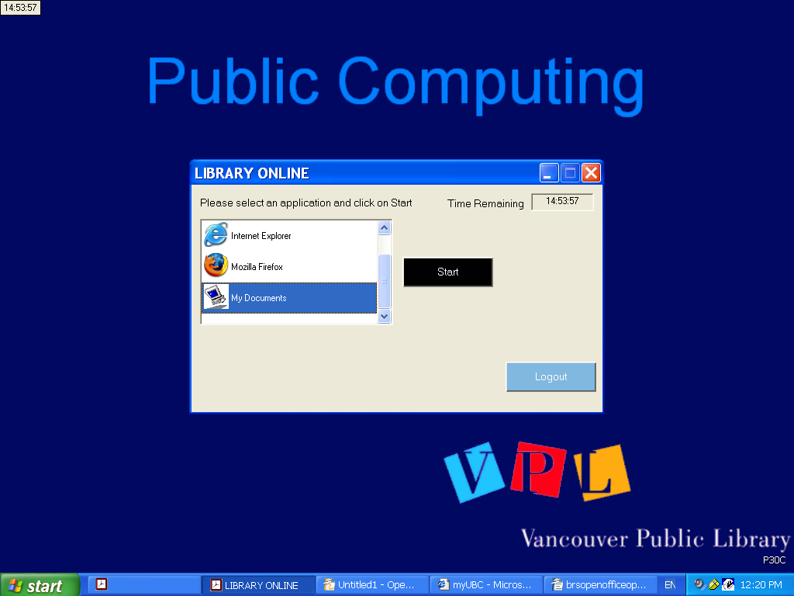



Select the drive where your document is located:

* CD: DVD-RAM Drive (D:)
* USB Device or "Thumb Drive": Removable Disk (E)
* Or, from My Documents [USER (U:) My Documents] if saved temporarily during your OpenOffice session (Note: these files will be erased once the computer is rebooted)

Click on the filename, and your file will open in the appropriate OpenOffice program automatically.

Opening documents from OpenOffice

Choose **File** > **Open**.

Select a file name and click **Open**.

Formatting

If your document was created in Microsoft Office, the formatting may appear differently. Select the text that requires adjusting, and go to **Format** > **Paragraph**.

For help with Formatting in Writer:

* select **Help** > **OpenOffice.org Help**
* select the **Contents** tab, then click on **Text Documents** from the list
* select **Formatting Text Documents**

Saving Your Work

Save regularly during your session. Your session is timed, and you must save your documents to an external device before your time runs out. Any files saved in My Documents will be erased when your session is over, or when the computer is rebooted.

To save a document, from the options located at the top left of your document window, choose **File > Save As or File > Save**. You can also click on the **Save** icon on the function bar.

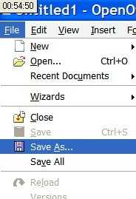 

1. **Select where you want to save your document**. The pulldown menu **Save in:** will provide options such as:
   * My Documents - for saving temporary files in the hard drive. These will be erased once your session is over and the computer is rebooted. These files cannot be retrieved.
   * CD (D: drive) -- will appear when you insert a CD. Details are below.
   * USB -- will appear when you insert a USB device.
2. **Create a file name**. Name your document something descriptive and recognizable.
3. OpenOffice will recognize most standard extensions (.doc or .xls or .ppt), but it may apply one of its own extenstions (.odt). You can choose to save your documents with other file extensions: **select a file type** from the dropdown menu.

**CD**

You will need a writeable CD (CD-R or CD-RW). Saving to a CD is a two-step process. At first the document is saved. The second step is to write (or "burn"), the files to the CD. *Be sure to leave enough time to do this before your timed OpenOffice session runs out.*

(When you insert your CD a window may appear when you insert a new disc asking you to make a selection from some options. If the disc is empty, choose "Take no action" and click Cancel.)

1. In Open Office -- **File - Save As** your document to the **E: drive**
2. Close the OpenOffice program (important step)
3. Go to the **LIBRARY ONLINE** menu and choose **My Documents**
4. Choose the **CD Drive E:** drive from the address bar.
   * Your document should appear under the heading:  
     **Files Ready to be Written to the CD**
5. Go to **File > Write these files to CD**
6. The CD Writing Wizard window will appear. Name your CD or just use the default date. Click Next, and wait for the writing process to complete, and then click Finish. (Your CD may then eject automatically.)

**USB / Thumb Drive / Flash Stick / Memory Key**

1. Insert your USB device.
2. In Open Office -- **File -- Save As**
3. From the **Save In** drop down menu, select the **U:** drive and then **Save**.
4. To check that your document has been saved, go to the **Library Online** menu, and choose **My Documents.**
5. **Choose the U: drive** from the address bar and look for your document**.**

**Saving as a PDF**

1. Go to **File** -- Export or File -- Export as PDF (or, click on the PDF icon on the icon bar at the top of your document). A window will appear.
2. Click on **Export**. An Export window will open.
3. Choose a name for your document and to location where it will be saved.
4. The file format **.pdf** must be selected.
5. Save to the desired location.

|  |  |  |  |  |  |  |  |  |  |  |  |  |  |  |  |  |  |  |  |  |  |  |  |  |  |  |  |  |
| --- | --- | --- | --- | --- | --- | --- | --- | --- | --- | --- | --- | --- | --- | --- | --- | --- | --- | --- | --- | --- | --- | --- | --- | --- | --- | --- | --- | --- |
| Printing your work  Click the **Print File** icon on the function bar, or select **File > Print** for more options.   |  | | --- | |  |  |  |  | | --- | --- | | http://www.vpl.ca/images/uploads/image/using_the_library/print1.jpg | http://lgimages.s3.amazonaws.com/data/imagemanager/36119/print2.png  To make changes to your print job, click on the **Properties** button in this window. |   http://lgimages.s3.amazonaws.com/data/imagemanager/36119/print3.png   |  |  | | --- | --- | | This window enables you to change the paper size, choose 1-sided or 2-sided, etc. Please note, the default printer settings is double-sided. | | | Once you have made any necessary adjustments, click on the **Okay** button then on the **Print** button. | | | Your document will be printed to the public printer in your branch. At Central Library, there is a public printer on each floor. | | | To retrieve your print job, please make note of the number on the top of the monitor. | | |  | | | **Selecting paper size:** The document can be printed in a standard paper size: 8.5 x 11 (letter), 8.5 x 14 (legal) or Tabloid (11”x17”);  **A4 is not an option**. Through Properties, printer will adjust non standard sizes (ie A4) to standard paper sizes. |  | |  |  | | To change the paper size | | | 1. Select File > **Print** | | | 2. Click on the **Properties** button. | | | 3. Choose the size of paper from the **Original Size** drop down menu. | | | 4. The choice under **Paper Size** will be **Same as Original Size.** | |  Formatting If changing the paper size of your document, you may need to adjust the formatting: Use **File > Page Preview** to view your document before printing.  For help with Formatting in Writer:   * select **Help > OpenOffice.org Help** * select the **Contents** tab, then click on **Text Documents** from the list * select **Formatting Text Documents** from list |  |
|  | |
|  | |
|  | |
|  |  |
|  |  |
|  |  |
|  | |