

**Getting Started With Flickr!**

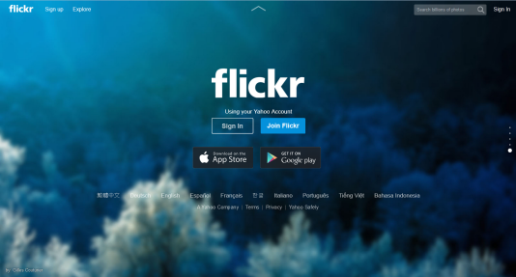

**Creating an account**

**1)** Visit <http://www.flickr.com/>

**2)** Select “Sign up for Flickr”

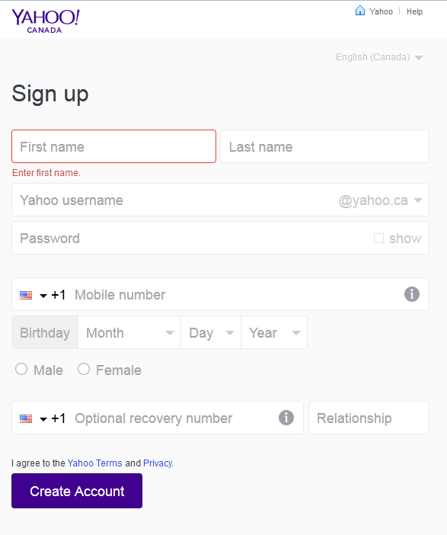**3)** Flickr has a partnership with Yahoo! so if you have a Yahoo! account you can sign in with that. Alternatively, you can sign in with Facebook or your Google account.

If you do not want to use any of these options, you can select “Create New Account”

**4)** If you are creating a new account you will need to fill in some information and choose a password. For the other options it will ask for your email and password for option you chose.

Ex:  *Google account*: [example123@gmail.com](mailto:example123@gmail.com)

*Password:* 12344321

**5)** Time to choose a Flickr “Screen name”. This is the name that will be associated with the photos you upload. You can change this name at any time.

**6)** When you have filled in all of your information choose “Create Account”

**You now have a Flickr account!**

**7)** At any time you should be able to see a black bar near the top of your screen. This will allow you to navigate to your own page, to your friends’ pages and upload photos.



**8)** If you would like to add friends, put your mouse over “People” and select “Find Friends”. From here, you can choose contacts from a variety of services including Facebook, Yahoo, or Gmail. Adding friends means that you will be able to easily find and view their photos.

**Uploading Photos to Flickr**

**1)** Select “upload” from the top bar 

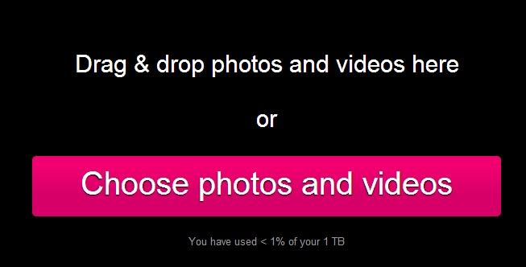

**2)** Select “Choose photos and videos”

**Locating photos on your Camera**

1. Plug in camera (or chip) into your computer
   1. Some cameras need to be turned on
   2. Some cameras also need to “connect to PC” selection to be made
2. Choose “Open folder to view files” from the pop-up window that appears
   1. You can also go to “Computer” from your start menu
3. Double-click on either “Removable Disk” or the image of a camera
4. Choose **DCIM**
   1. **Note:** You may have other folders to click on – for example 101_Pana or 102Canon, it depends on the camera! If you get lost, just click on the back button and try another folder.

The more often you do it, the easier it will get!

**3)** Navigate to the photos you want and either drag them onto the page or select them and click “open”

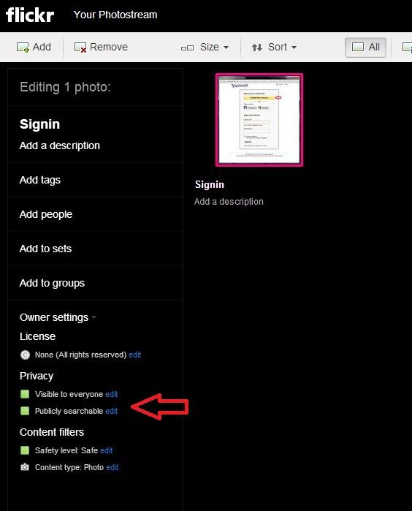**4)** Before you upload the photos, you can choose who gets to see them. Click on the words at the lower left hand corner that say “Visible to everyone” to make your photos publically viewable.

**5)** When all of the photos you want to upload are on the page choose “upload” in the top right hand corner

**6)** A “set” is a group of photos that you would like all in one place. For example, if you had photos of a birthday party you could create a “birthday party” set. If you would like to add the photos to a “set”, choose the photos you want to add and click “Add to sets”. If you already have sets created, you may select one, or you can create a new set.

**7)** When you are done grouping your photos and choosing the privacy setting, you can click “Upload” in the top right hand corner.

**Now your photos are on Flickr!**

**Editing Photos in Flickr using Aviary**

1. Choose a photo to edit
2. Click on the “Edit Photo” button 
3. Choose “Enhance with Aviary”
4. Using the editing tools (details below) edit your photo
5. After you finish with each tool click on “Apply” 
6. Click on “Save” when you are done editing. 
7. Choose to rename the photo, or create a copy, you can also change the privacy settings at this time

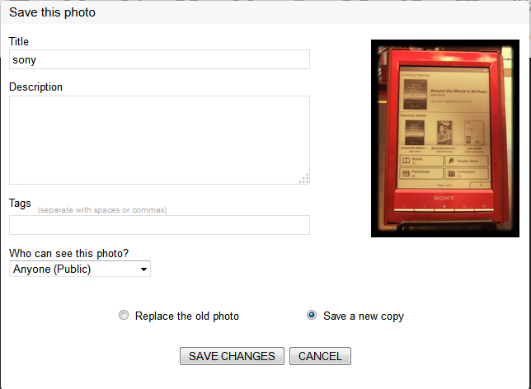

**Additional Tips**

**Privacy**

Change your default settings here: <https://www.flickr.com/account/prefs/photoprivacy/>

Flickr’s Privacy and Sharing FAQ: <https://help.yahoo.com/kb/flickr/privacy-settings-sln7317.html>

**Sharing with Friends and family!**

* Click on the https://farm4.staticflickr.com/3784/8759026144_abe5437af9_o.jpg icon and choose email, facebook, or other websites.
* More here: <https://help.yahoo.com/kb/flickr/SLN7387.html>
* More on the “Guest Pass”: <https://help.yahoo.com/kb/flickr/guest-passes-flickr-sln13039.html>
* “If you want to share private photos with people, use a Guest Pass. You can grant anyone access to the entire contents of one of your sets, including any private photos it contains. A Guest Pass is actually just that URL. This means that whoever sees that URL can access the set and all the photos inside it.”

**Official Flickr Help**: <https://help.yahoo.com/kb/flickr>

**Aviary Tools**



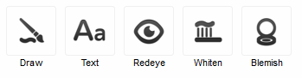

**Enhance**: 4 options to change the light in your photo

**Effects**: colour filters  - example “Boardwalk” gives a photo a sepia tone, while “Dean” makes everything blue-toned

**Frames**: adds different types of frames to a photo – from plain white frames, to stamp frames

**Stickers**: Add silly stickers to your photo – you can resize and rotate to better add a tiny bowtie to a turtle.

**Orientation:** rotate or flip your photo (good for photos taken with a phone).

**Crop**: Crop out parts of the photo that you wish to remove – or make it the size and shape that you would prefer

**Resize**: changes the size of the photo (for emailing or posting to a website like facebook)

**Focus**: makes one part of the photo clear, and blurs the rest.

**Warmth**: adds warmth (red tones) or coolness (blue tones)

**Brightness**: brightens dark photos or darkens overexposed images.

**Contrast**: sharpens or shortens elements of a photo

**Saturation**: enhances colours

**Sharpness**: improve contrast by enhancing edges

**Splash**: turns a photo black & white and you choose to make one colour or object have colour

**Draw**: lets you draw on the photo

**Text**: lets you add text to an image

**Redeye**: removes redeye

**Whiten**: use to whiten teeth

**Blemish**: removes skin blemish (matches the area to other skin areas)