Launch Party – Tekeyla Friday

Week: Dance Party July 5th 2016 Time: 1 – 3pm

Subject: Games, activities, Lego stop-motion, pompom creatures, card character craft

Topic:

Content:

Lesson Preparation:

- Up In The Sky Dance
- Cat In The Hat Game
- Minute to win it dancing balls
- Freeze Dance
- Pin the tutu on the ballerina
- Door prize entry slips
- Door Prize

Presentation: Group style – two leaders

- Up In The Sky Dance (TD Suggestion)

Game 10 minutes

  - 1. Explain to the group that they will be playing a game and the goal is to keep their cloud-shaped tissue paper from landing on the ground. If they catch their cloud before it hits the ground, they can start again with it on their head. But once it hits the ground, they are out of the game.
  - 2. Give participants a cloud and ask them to put it on their head. Turn on the music and let them walk around the room first to practice. Once they are comfortable with the activity, instruct them to dance the next time the music starts. Note that participants are not allowed to simply hold the cloud in place with their hands.
  - 3. Start the music and begin dancing! Participants try to keep the cloud on their heads. If the cloud starts to slip, they can catch it and start again. If the cloud lands on the ground, the participant must sit down and is out of the game.
  - 4. Kids still in the game can collect fallen clouds and place them on their head in addition to their own cloud.
  - 5. After an allotted time, turn off the music. The kid with the most clouds is the winner.

- Limbo

Game 10 minutes

  - Using a long tube, have the students take turns limboing beneath the tube.
  - With each round, lower the stick to see how far the students can go.

- Freeze Dance

Game 10 minutes

  - Have students dance in a cleared centre.
  - When the music stops, students must freeze.
  - If a student is still moving when the music stops that student is out.

Two Stations

Split students into two groups. Group one will play Minute to win it dancing balls for about fifteen minutes. The second group will play Cat In The Hat and Pin the for fifteen minutes.

Station 1 – Minute To Win It

- Take several tissue boxes or cardboard boxes filled with balls. Attach the boxes to participants.
- Turn on music.
- The participants must dance erratically in order to bounce the balls out of their boxes. The first one to bounce all the balls out, wins!

Station 2 – Cat in The Hat and Pin The Tutu On The Ballerina

- Split the children into two smaller groups.
- Explain the instructions for the Cat In The Hat Game to the Children.
- Once they start playing that the other group to the Ballerina game.
- Using the large picture of the Ballerina, have children stand in a line.
- As each child come forward to be blind fold him or her and give him or her a tutu.
- Spin them gently around three times and face them towards the ballerina.
- Then that child must pin the tutu on the Ballerina.
- The first to pin the tutu on the Ballerina the right spot, wins.

Once the kids take their turns, switch them between the Cat In The Hat game and the Ballerina game. If there is still time, switch the two groups so that Group 1 goes to the Cat In The Hat game and Group 2 goes to Minute To Win It.

Outline For TD Summer Reading Club ~ 2016

Tekeyla Friday

Week 1 ~ Launch Party: Dance Party July 5th 2016. Time: 2-3p.m. (storytime) Ages 3 - 5

Subject: Stories, Rhymes, Songs and puppet show with a theme

Topic: Tutus, dance and creativity

Content: Rhymes, Songs, Magnet Board Story, Stories and puppet show

Kid’s Corner Note: According to the Artsy Toddler Storytime by Carol Hopkins (pages 2 – 9): it’s a great idea to remind and remind and remind parents to supervise their children while participating in a Library Storytimes especially during craft time. Craft foam, large buttons, cotton balls and other small objects can be choking hazards. Plus children normally require help from an adult. Staff can lend a hand but it’s best that the parent is there to help his/her child. Stoyrtime is not a drop off program and parents and grandparents need to be aware of this. We cannot watch 12 to 30 children and according to daycare standards that is illegal. Any program involving pre-school age children need a 1 to 3 ratio (A.K.A. 1 adult to 3 children). Parents need to be on the premises. I do ask parents to be quiet during the program as I don’t like to compete with adult conversations especially during puppet shows. Should the parents need to visit during the reading the program, I ask them to got to the reference section. Too much adult conversation is distracting for the kids and hard on my voice. It’s hard to keep the children under control when the adults are teaching them a poor example.
Lesson Preparation:
Storytime Lesson Preparation:

- Book: Yellow Tutu
- Book: The Only Boy in Ballet Class
- Rhyme Booklet
- Puppet Script (2 copies) Emily Wild learns to dance
- Puppets ~ Emily Wild
- Props ~
- Craft – Ballerina Card, Fancy Mask and Tutu elastics
  - Elastic hair bands
  - Tooling
  - White card stock
  - Coloured card stock or scrap book paper
  - Ballerina tempates
  - Mask Templates
  - Feathers
  - Skewer Sticks
  - Markers
  - Glue Sticks

Literacy Objective: Based on the TD Summer Reading Club Program this is an initiative to help students keep up their reading levels in school and to introduce children to new books.

Presentation:
- Using the Storytime Rhyme booklet sing the Welcome songs
  - Welcome To The Wild
  - Dance Your Fingers

- Story: Yellow Tutu

- Rhyme: Off She Goes

- Magnet Board Song: Jazmine Wore A Blue Tutu

- Finger Play: Five Little Dancers

- Story: The Only Boy In Ballet

- Magnet Story: Carrots Don’t Dance

- Song: Hokey Pokey

Script: Emily Jungle Dancing
Craft: Ballet Card, Tutu Hair Ties and Masks
Card – take a girl template and paste her in the middle of a folded piece of card stock. Next choose a fancy piece of scrapbooking paper. Fold the paper like a fan and glue it to the middle of the girl’s waste like a skirt. Decorate as desired.

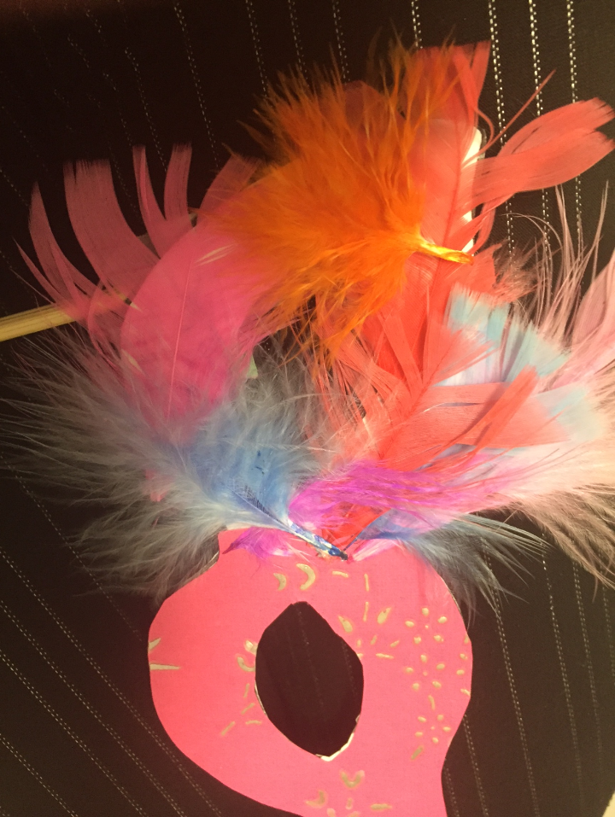
Mask – using mask template. Colour, or glue paper or feathers on it. Then tape to a skewer stick (cut skewer stick tip off.)

Hair Ties- Using pre-cut tulle loop the strips around the elastic band. Keep looping tulle around the band until it is completely filled. Ribbon will work too.
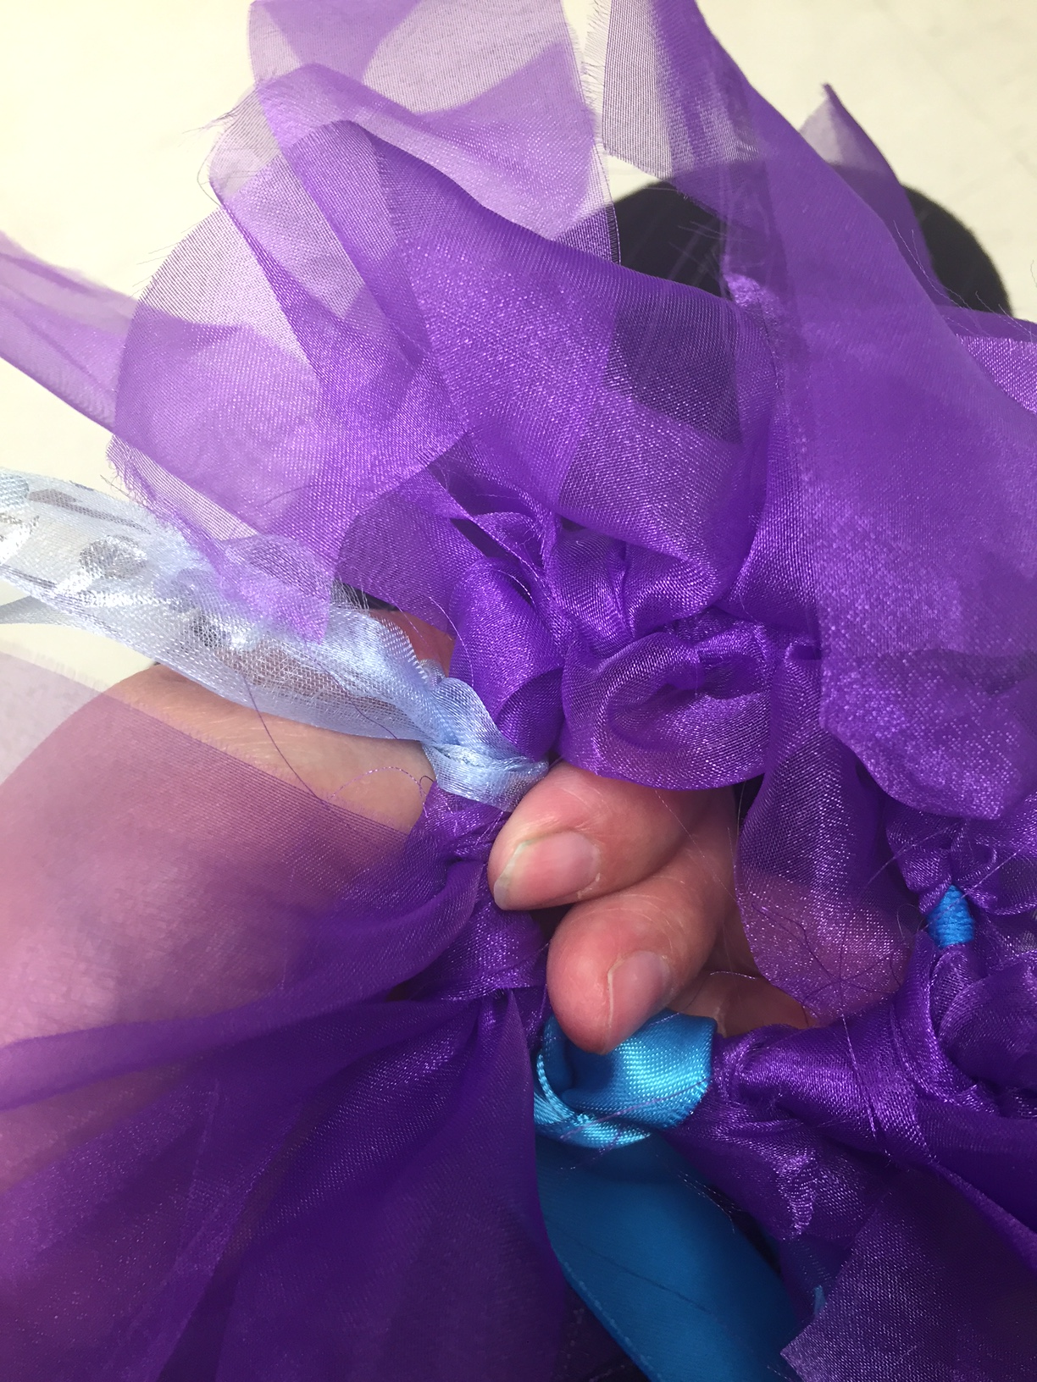

Maker Kids

Subject: Technology. Tuesday, July 5th 2016. Time: 2 – 3 pm Children ages 6 – 13+
Topic: Creativity
Content: Lego Stomp Motion Animation, Makey-Makey
Presentation: Ipads, Lego, Makey-Makey, Laptops
- Makey-Makey panels
- Connection wires and USB cables
- Bananas
- Laptops
- Ipads
- Lego
- Backgrounds
- Large bookends
Directions: Hook the USB cable into the Makey-Makey panel. Attach six wires and connect to bananas. Use the Makey-Makey website http://makeymakey.com/apps/ Click on desired application. Let the children touch the bananas to make sounds, play Tetris or other cool features.

Lego Stop Motion Animation – Download Lego Movie App. Set up backdrops on Large bookends (any landscape background will work). Set the backgrounds out on tables along with a pile of Lego and the Lego characters. Let the children build a scene and use the Ipad to film their movie.

