Playing Minecraft in Creative Mode

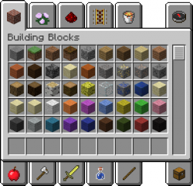
Creative mode is all about building and creating amazing things. Players are given an infinite number of blocks to build with and no health or hunger bar thus rendering the player immune to all damage. Taking advantage of this, players can create large constructions more easily.
Getting Started
Players will have two types of inventory. The creative mode inventory which can be accessed by pressing “E” will give the player access to all the blocks, items and crafting materials available. The player can scroll and browse through the tabs to see all the items they can use. The regular inventory where they can craft and manage their gathered materials is also available (This inventory is not necessary with the creative mode inventory)
Moving Around
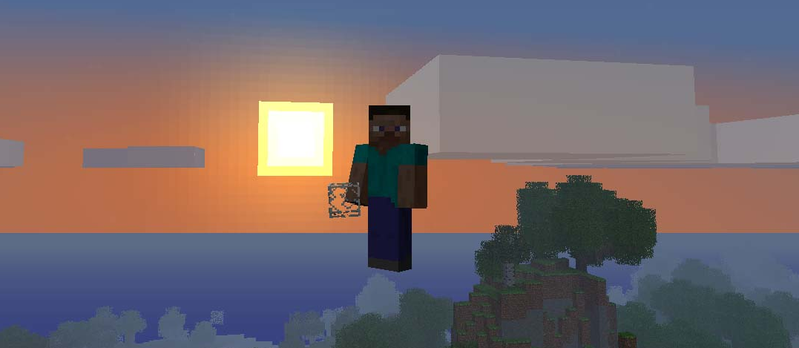
Players can build and destroy blocks instantly which makes building projects and experimenting very easy. The player can also fly by pressing the jump button twice and using the space bar to move up and the shift button to move down. Moving in different directions works the same in the air as on the ground (AWSD keys) again, the player is immune to damage in creative mode so feel free to play around and get used to the controls
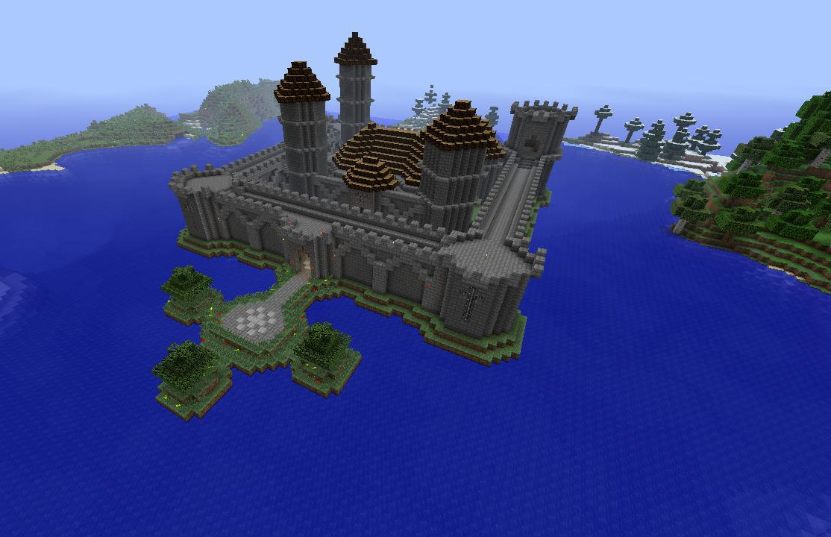
Happy building!
