Creating and Launching a Minecraft World using a MinecraftEdu server
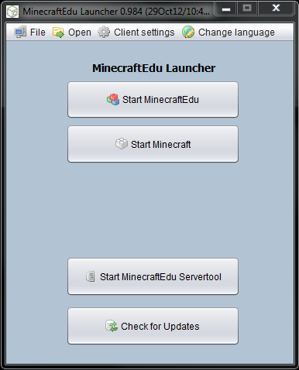
When hosting a Minecraft program, you have to launch a MinecraftEdu world using a MinecraftEdu server.
A MinecraftEdu server is the central computer on which the MineraftEdu world is running. MinecraftEdu clients connect to this computer over a local area network (lan) or the internet using MinecraftEdu.
Step 1) Run the MinecraftEdu Launcher. (This should be found in the “Gaming” folder on the desktop of each Digital Mobile Lab.)
Step 2) Click the “Start MinecraftEdu Servertool” Button.
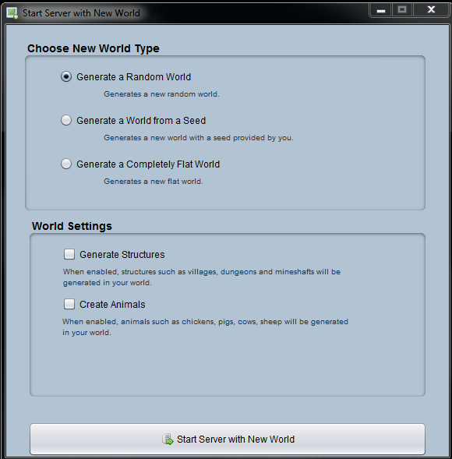
Step 3) Click the “Create New World” Button. (The start Server with Tutorial world button will launch a world intended to teach people the basics of mine craft such as controls, how to craft etc… however if you want to jump in and start building and having fun you will want to select “Create New World”.
Step 4) Under “Choose New World Type” select either “Generate a Random World” or “Generate a Completely Flat World.” The advantage to selecting a flat world, is that it is easy to create structures in such an environment, however the world is not very deep and if you mine too far, you will fall through. If you select a random world, you will have mountains, deep caverns and other great geological features.
Step 5) Under “World Settings” you can choose to select or leave blank “generate strucutres” and “create animals.”
Step 6) You will now see the “Minecraft Server” Window. You can use this window to adjust server settings and issue commands that affect players on your server.

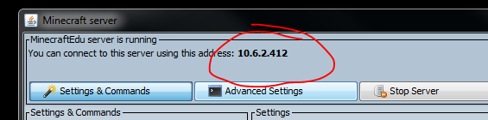
Step 7) Write down the ip address for your server. Program participants will use this number to connect to your Minecraft Edu server.
Step 8) Under settings, click on the “Change server teacher password.” Remember this password, as you will need to use it to sign on to the server as teacher in order to access the “Teacher” commands.
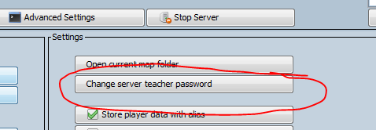

Congratulations! You have successfully set up your MinecraftEdu server and world!
For more information visit the MinecraftEdu wiki: http://minecraftedu.com/wiki/

