KidsZone Program Report

Date

Program description
Today was Book Bingo! Each place at the table had a blank bingo sheet, three sheets of book cover photos and one sheet of blank book cover images. They started by adding the title of their favourite book to the blank book cover in the ‘free spot’ at the center of the sheet. They then choose from 9 book titles for each column and cut out miniature pictures of the cover to glue on. When their Bingo sheets were full we played until everyone had won a small prize.

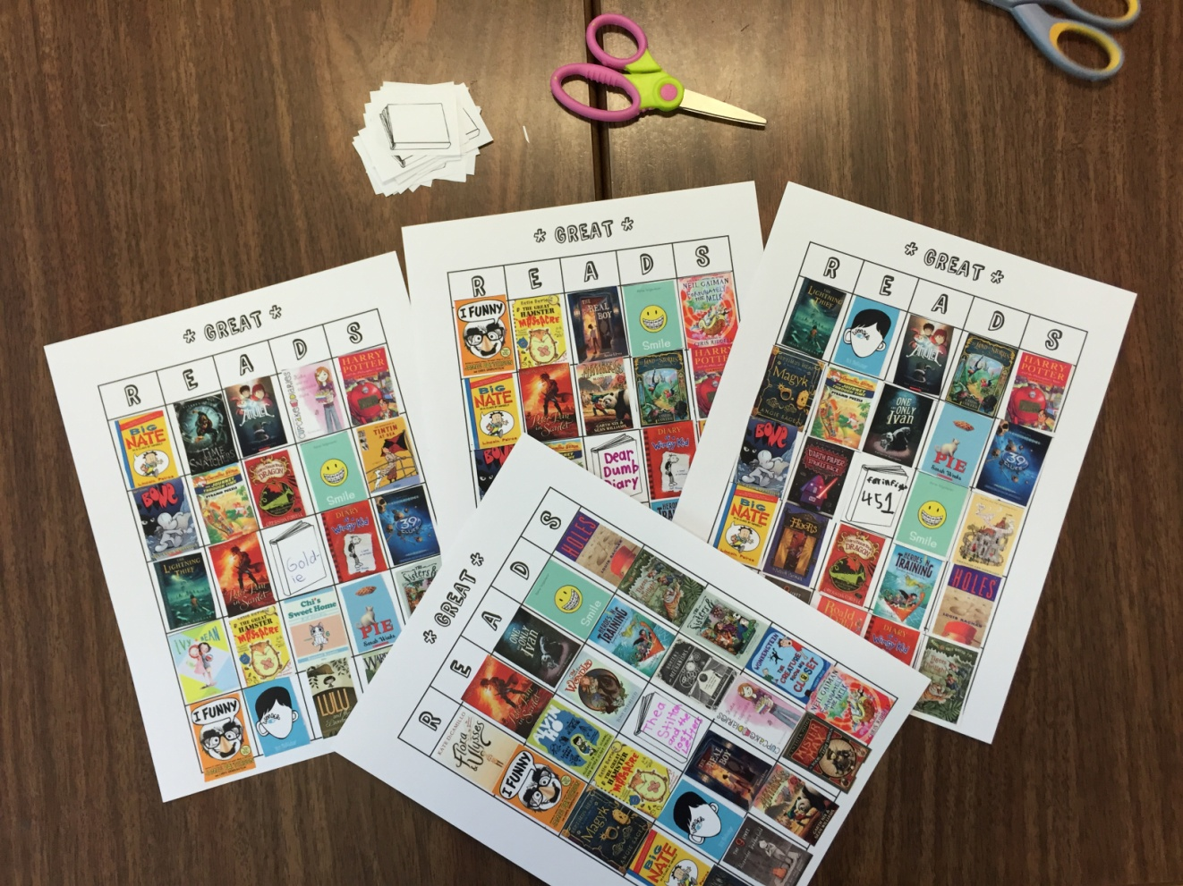

Attendance > |  | 6
Observations
The best part of Book Bingo is listening to the conversations that the participants have while cutting out the mini book covers to populate their sheets. They talk about which books they’ve read, which ones they want to read and end up recommending titles to each other. One boy attempted to fill his sheet with only books that he’s read (though he couldn’t quite do it). As everyone cut and glued, we chatted about which books have been turned into movies, what everyone put as their ‘free spot’ book. When we were done, three of the participants took home their Bingo sheets and are going to use them to challenge themselves to read all of the books on it (or at least one Bingo’s worth).

Feedback
Everyone had a lot of fun playing Bingo. They decided to finish off with a ‘blackout round’ to see who could fill up their entire sheet first. I had Apple to Apples (a group favourite) in case we had some extra time, but we Bingo’ed right until 5:00.

There was quite a bit of discussion about upcoming programs today. Everyone chipped in on what they’d like for Halloween and reminisced on past programs. A few are participants who attended this time last year and asked for repeats of some of the same programs (ie. DIY Board Game).

staff  (name(s)) |  |  |  | Reported by:

