Welcome, Bonjour & Tansi!
Welcome to the LEGO Programming Kit. This kit comes stocked with LEGO activities and challenges for all ages. With the help of this kit, we hope to bridge the gap between critical thinking and creativity. Give it a try with children, teens or adults in your community!
Inside you will find all necessary inspiration to help you create your very own LEGO program. The possibilities with LEGO are endless, so please us the internet as a source of inspiration. Additional handouts from WisCode Literati and LEGO challenge cards have been included in this manual. Please refer to the Wapiti Regional Library Pinterest page for all our LEGO Learning related favourites.
https://www.pinterest.com/wapitiregion/lego-learning/
Upon completion, please fill out one of the feedback sheets located in the back of the manual. Your comments and suggestions will help us improve our programming kits.
Happy innovating!

The Wapiti Regional Library Team

STEM in the Library
STEM is an acronym for science, technology, engineering and mathematics. STEM has been appearing in libraries frequently over the past decade. Activities based around the STEM model promote critical thinking for all ages.
The LEGO Programming Kit comes with STEM based activities and challenges which we hope branch librarians can use as inspiration. We hope to provide a well-rounded set of activities which can be used in groups or individually. Group activities promote collaboration.
The following layout is recommended:
- Introduction to the session’s theme. For example:
  - Coding
  - Mathematics
  - Buoyancy or Gravity
  - Language development
- Allow the participants to troubleshoot their designs. If they are stuck, prompt them with questions.
- After the challenge is complete, allow the participants to have an opportunity to design freely.
- Finally, tour the creations. If the participants are comfortable have them present their designs.
LEGO Challenges
Each of these challenges is designed to promote a STEM concept. Participants will be asked to make predictions, conceptualize their designs and make discoveries through trial runs.

Zip Line Challenge
Description
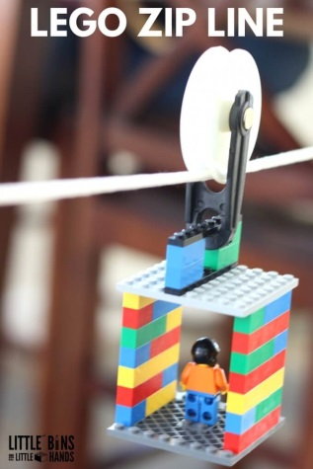
This challenge teaches the participants about gravity, slopes and rope tension.
Can be completed in pairs or individually.
Supplies
- Rope (clothesline)
- Pulley mechanism
- LEGO figures and blocks
Instructions
- Depending on the age group, the “zipline” rope can be set up in advance. Attach the rope from two fixed points in your library or have the kids create their own launching towers.
- Set a goal & building time frame.
  - For example: Build the fastest transporting zip line in 15 minutes.
- Pass around activity sheets and allow participants to draw or descript their design.
- Trial 1: Allow participants to test out their designs. Record results on their activity sheet.
- Trial 2: Can consist of a new challenge or participants can improve their design.
Additional Options and Questions:
- How does adjusting cargo weight change the speed of their design?
- Does adjusting rope tension alter the travellers speed?
- How can you increase or decrease speed?

Balloon Powered Car Challenge
Description
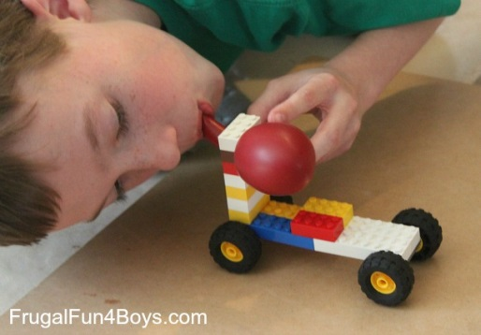
This challenge will test participant’s ability to examine a vehicles performance based on its weight distribution.
Supplies
- LEGO and wheels
- Balloons
- Measuring tape
Instructions
- Setup a race way on a flat even surface. Use masking tape to mark a start and finish line.
- Pass out activity sheets. Have participants draw or describe their design. Provide a set building time.
- Trial 1: Test designs and record results on activity sheets.
- Trial 2: Can consist of a new challenge or can provide participants with an opportunity to adjust designs.
Additional Options or Questions
- Build the fastest or furthest travelling car.
- Adjust the weight transported by the vehicle. Record the results.
- Build a ramp, have vehicles travel up or down.

Catapult Challenge
Description
This challenge teaches participants about tension.
Supplies
- LEGO and baseplates
- Elastic bands
- Optional: Candy to catapult over the finish line.
Instruction
- Explain the goal of the challenge.
- Pass around activity sheets and provide a set building time.
- Trial 1: Test out design and record the results.
- Trial 2: Can consist of a new challenge or can consist of improving designs.
- Go to Little Bins for Little Hands online blog for a step by step description.
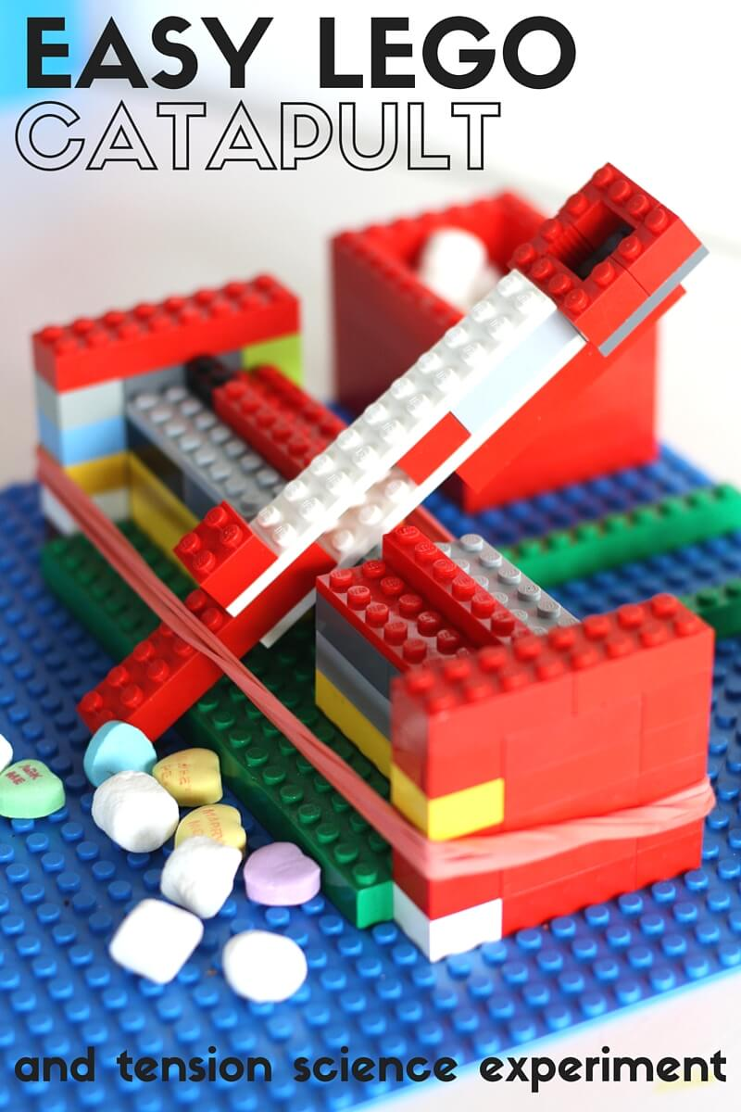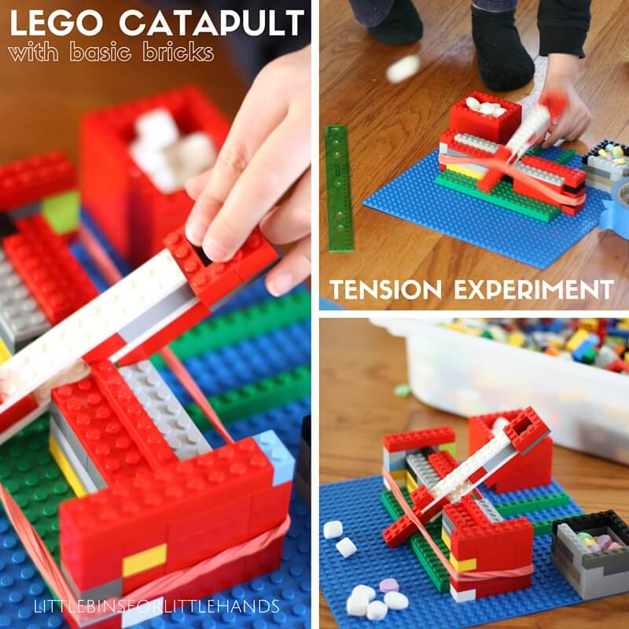

Boat Challenge
Description
The purpose of this challenge is to see how many pennies participant’s boat can hold before they start to sink. This challenge teaches buoyancy principles.
Supplies
- LEGO bricks
- Container of water
- Pennies
- Optional: Timer
Instructions
- Explain the purpose and goal of the challenge.
- Hand out activity sheets and have participants design their boats.
- Provide a set building time frame.
- Trial 1: Test out boats. Do they float? If needed, allow them to redesign.
- Have participants predict how many pennies they believe their boat will hold before it begins to sink.
- Trial 2: Have participants slowly add pennies, one by one. Record the results.

Maze Challenge
Description
This challenge is best completed individually. The goal is to build the most difficult maze for which a marble must travel.
Supplies
- LEGO & baseplates
- Marbles
Instructions
- Explain the goal, which is to create the most challenging maze.
- Encourage them to get creative (ramps, dead ends)
- Set a building time frame (10 minutes). Remind competitors that there must be at least one route wide enough for the marble to travel.
- Randomly assign challengers and have them race a marble through their opponent’s maze. To move the marble, hold the tray and gently tilt it back and forth so that the marble rolls.
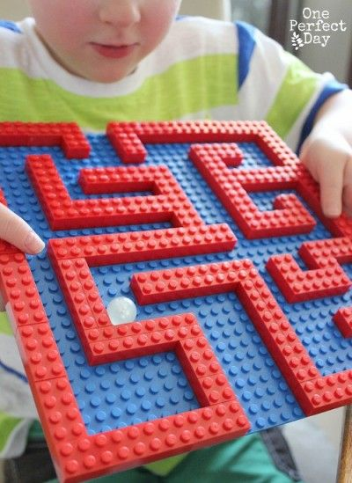

Inventory
Returning the LEGO Kit
- Please make sure to return the LEGO Kit when it’s due. Late returns result in delays for other libraries.
- There is an inventory list. Please check the list as you repack the kit to ensure all items are returned.
  - We DO NOT expect every piece of LEGO to be counted.
- Please report any damaged items so that the Regional team can find replacements. Thank you!
Item | Quantity | Quantity Returned | Comments (damaged, missing, etc.)
The LEGO Ideas Book  By: D. Lipkowitz | 1
LEGO Classic Brick Box | 2
Supply Kit  (will be replenished as needed) | 1
Black plastic organizer | 1
Wood checker board | 1
Comments/Feedback
Date:

