Canva: Getting Started

Canva is a free graphic design tool website.

Create an account

You need an account to use Canva. If you haven’t already created one, go to www.canva.com and create one. You can sign up with your Google account, Facebook account or email account.

If you already have a Canva account, go to www.canva.com and click Log in. Log in with your account credentials.

Test Yourself: Log into your Canva account.

Find a template

You can find many different kinds of templates on Canva. All of the templates are fully customizable. This means you can add your own branding, images, and text to them.
Here are just some of the templates you can find on Canva:
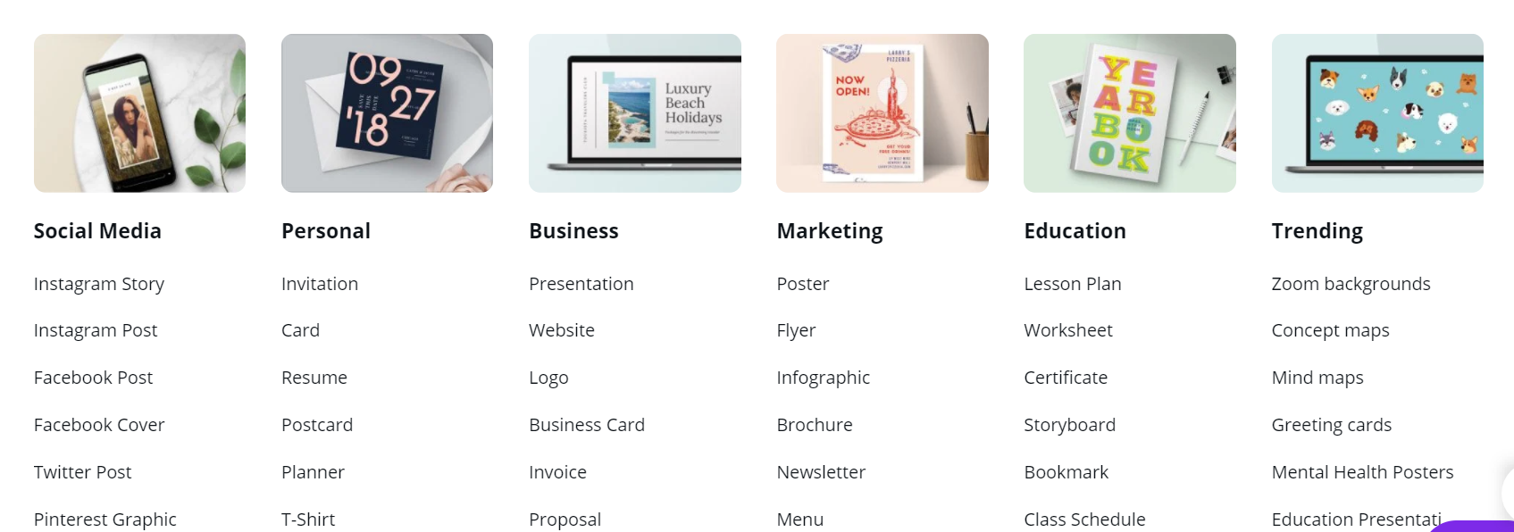

Test Yourself: Locate the invitation templates by typing “invitation” into the search box and pressing Enter on your keyboard.
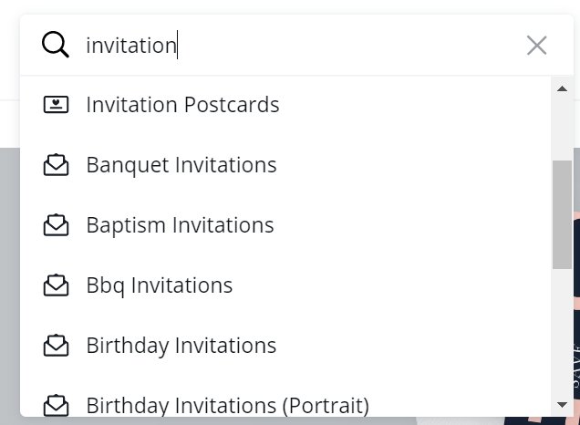

Find a template you like and double click on it to select it.

Work with free photos and graphics

Canva has a number of photos and graphics you can use in your project. Some of them are free and some are paid. The free photos will not have a logo in the bottom right corner or will say FREE in the bottom right corner. Paid images will have a crown logo on them.

Click Photos to search for photos (or Graphics to search for graphics).

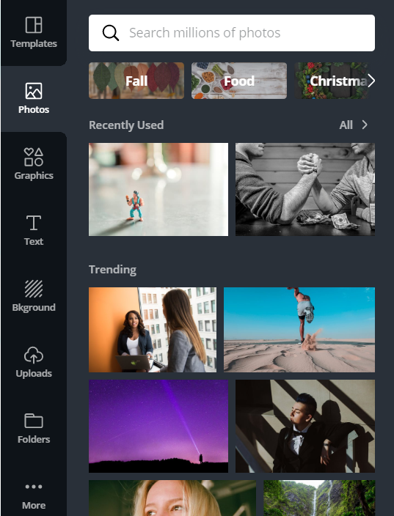

Type your search term into the search box.

Test Yourself: Do a photo search for “green door”. Hover your mouse over the first four images. Are they free or paid?

To add a photo or graphic to your project, double click on it or click and drag it into your project.

Test Yourself Further: Add a free green door photo or graphic to your project.

Resize photos and graphics
Click on the image you’d like to resize. Mouse over the corner of the image. A resize mouse pointer should appear . Click and drag out from the image to make it larger. Click and drag towards the centre of the image to make it smaller.
Test Yourself: Make your green door larger. Zoom in on a single detail that interests you.

Move photos and graphics
Click on the image you’d like to move to select it. Mouse over near the centre of the image. A move mouse pointer should appear . Click and drag the image to the desired location. Release to place the image there.
Test Yourself: Position your green door so the focal point is in the top third of your ebook cover.

Rotate photos and graphics
Click on the image you’d like to rotate to select it. A rotate icon will appear beneath the image. Click it and drag the image to the desired rotation. Release to place the image there.
Upload images

You can also use your own photos and graphics in Canva. The photo needs to be saved on your computer or portable storage device first.

Click Uploads. Then click Upload an image. A file explorer pop-up will appear. Select the image you would like to upload and click Open. The image will appear in your image bank. Double click it to add it to your project.

Test Yourself: Upload an image from your computer.

Test Yourself Further: Add the image to your project

Experiment: Move, resize and / or rotate the image until it looks the way you want it to.

Work with text

The template you choose will come with pre-selected fonts and place holder text. You can customize the text by double clicking the text you’d like to change. No cursor appears so it can be confusing. Add your text and erase the place holder text – use backspace to delete letter by letter. Be careful not to go too quickly or you will delete the whole text box. Use CTRL+Z to undo any mistakes.

Canva comes equipped with a limited number of tools to help you manipulate text. The tools are (from left to right): Font, Font size, Text color, Bold, Italics, Alignment, Uppercase, List and Spacing.

Test Yourself: Change the default text to your name.

Test Yourself Further: Change the font size to make it smaller.

Experiment: Use the available tools to make the text look the way you want it to.

Share your design on Facebook and other social media

If you have chosen a social media template, you’ll see Publish to Facebook. Click the arrow on the right to see more of your sharing options. Click on Show more to see all of your sharing options.

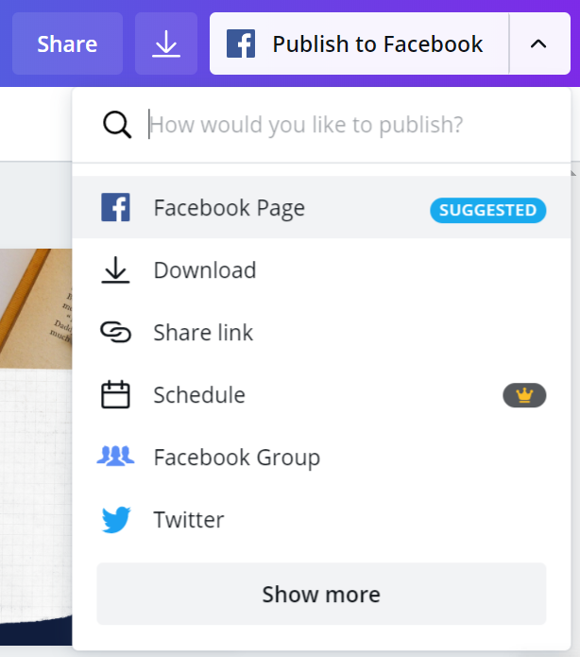

The first time you do this, you Publish to Facebook, you’ll be prompted to connect your Canva account to your Facebook account:

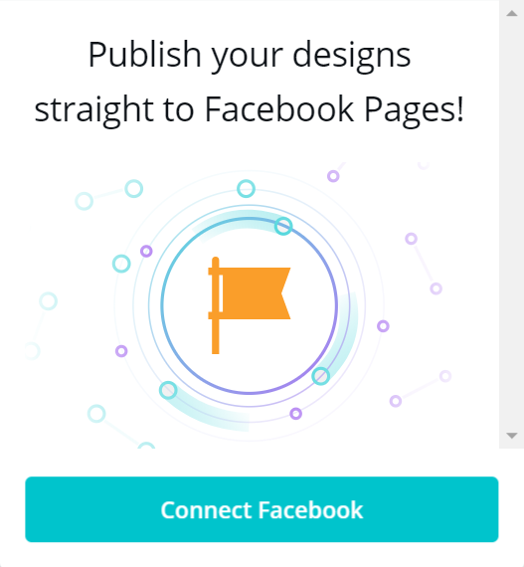

Once your Canva and Facebook accounts are connected, follow the prompts to share your post.

Download your design

Click Download to Download your design. A pop-up menu will appear. Click on the down arrow to choose your File type.
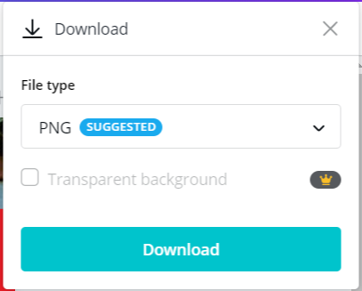
Once you have made your selection click Download. The design will be saved to your Downloads folder.
Learn more

- Canva tutorials: https://designschool.canva.com/

- Lynda.com courses:
  - Visit https://www.westvanlibrary.ca/research-learn/learn/online-courses-lectures
  - Click on Lynda.com and enter in your library barcode and PIN
  - You can also download the Lynda.com app. Under the Organization tab type in westvanlibrary.ca and click on Login. You’ll be taken out of the app to login through the website with your library card number and PIN. Use the app like you would the website, or download videos for offline viewing.
  - Search for canva

For more information contact LibraryConnect at 604.925.7400 or tech@westvanlibrary.ca

